

**User Manual   
for   
JD Cloud BDP Product**

**V1.1.1**

April 2018

**Copyright**

The copyright of this Manual is owned by Jingdong Shangke Information Technology Co., Ltd. Without the permission or authorization of Jingdong Shangke Information Technology Co., Ltd., any organization or personnel may not reproduce or disseminate this Manual and any of its text, contents and pictures by any means (electronically or mechanically) for any reason.

Copyright © 2018 Jingdong Shangke Information Technology Co., Ltd. All rights reserved.

This Manual may cover the patents (or pending patents), registered trademarks (or pending registered trademarks), copyright or other intellectual properties of Jingdong Shangke Information Technology Co., Ltd. Unless the express written licensing agreement is obtained from Jingdong Shangke Information Technology Co., Ltd., any licensing agreement to use such patents (or pending patents), registered trademarks (or pending registered trademarks), copyright or other intellectual properties will not be granted by this Manual.

Beijing Jingdong Shangke Information Technology Co., Ltd.

Website: <https://www.jdcloud.com/index>

Address: 5/F, Tower A, Beichen Century Center, Building 2, Courtyard 8, Beichen West Road, Chaoyang District, Beijing

I. Introduction 7

1.1 Objective 7

1.2 Product Introduction 7

1.2.1 Data Factory 8

1.2.2 Data computing service 8

1.2.3 Streaming data bus 8

1.2.4 Stream computing 8

1.2.5 JMR 9

1.3 Scope of Use 9

1.4 Revision Description 9

1.5 Definition of Terms 10

1.5.1 Task 10

1.5.2 Instance 10

1.5.3 Data set 10

1.5.4 Workflow 10

1.5.5 Script development 10

1.6 Function Module List 11

II. Quick Start 12

2.1 How to Create a JD Cloud Account 12

2.1.1 Register a JD Account 12

2.1.2 How to modify the account and bind the mobile 12

2.1.3 JD Cloud account real-name verification 12

1) Personal real-name verification 13

2) Enterprise real-name verification 13

3) Student real-name verification 14

2.1.4 View access key 14

2.2 How to Connect Data 14

2.2.1 Data and file types supported by Data Factory 15

2.2.2 Connection management - connectable services 15

2.3 How to Synchronize Data 16

2.3.1 Objective 16

2.3.2 Create synchronization task 16

2.3.3 Establish a data source end connection 17

2.4 How to Transport Data 18

2.5 Data Synchronization Task Management 18

III. User Guide for Console Operation 19

3.1 Data Factory 19

3.1.1 Function overview 19

1) Data synchronization 19

2) Synchronization task scheduling management 19

3) Monitor alarm 20

3.1.2 Connection product 20

3.1.3 Definition of terms 20

1) Data set 20

2) Connectivity of data set 20

3) Synchronization task 21

4) Workflow 21

3.1.4 Operation guide 21

3.1.4.1 Login to console 21

3.1.4.2 Connection management 22

1) Local file access 22

2) Data source configuration 23

a) Configuration of data source in cloud database 23

b) Configuration of cloud storage data source 24

c) Configuration of MYSQL data source 25

d) Configure SQLServer data source 26

e) Configuration of FTP data source 27

f) Configuration of Oracle data source 28

g) Configuration of DB2 data source 29

3.1.4.3 Data synchronization 30

1) Create synchronization task 30

2) Operation and maintenance of synchronization task 32

3.1.4.4 Workflow 32

1) Create workflow 32

2) Workflow operation and maintenance 35

3.1.4.5 Operation and maintenance center 36

3.2 Data Computing Service 36

3.2.1 Function overview 36

1) Massive data computing 36

1) Fully hosting and out-of-box use 37

2) Task development 37

3) User permission management 37

3.2.2 Connection product 37

3.2.3 Data source configuration 37

3.2.3.1 Data uploading 37

3.2.3.2 Library list management 37

1) Create database 37

2) Create datasheet 38

3) Upload data 39

3.2.3.3 File management 40

1) Create new folder 40

2) Upload file 41

3.2.3.2 Task development 41

1) Create development task 41

3.2.3.3 Job history 43

3.2.3.3 User management 43

1) Create user 43

2) Delete the user 44

3.2.3.4 Permission management 45

1) Library list authorization 45

3.2.3.5 UDF function 46

3.2.3.5 Built-in function 47

3.3 Streaming Data Bus 47

3.3.1 Function overview 47

1) Auto scaling 48

2) Easy access 48

3) Easy integration 48

4) Auto filing 48

5) Usability and user experience 49

3.3.2 Connection product 49

3.3.3 Operation guide 49

3.3.3.1 Create subject 49

1) Make preparations 49

2) Create subject 49

3.3.3.2 Data archiving 50

3.3.3.3 Access control 52

3.3.3.4 SDK introduction 53

3.3.3.5 Agent introduction 57

3.4 Stream Computing 62

3.4.1 Function overview 62

1) Auto scaling 62

2) Easy integration 62

3) Fully-hosted stream computing service 62

4) Usability and user experience 63

3.4.2 Connection product 63

3.4.3 Operation guide 63

1) Make preparations 63

2) Create application 63

3.4.3.1 Data input 65

3.4.3.2 Data output 67

3.4.3.3 Job development 69

3.4.3.4 Customized function 72

3.5 JMR 72

3.5.1 Function overview 72

1) Ease of use 72

2) Cost saving 72

3) Deep integration of related products 72

4) Security and reliability 73

3.5.2 JMR revision and related software 73

3.5.3 JMR billing instructions 73

3.5.4 Operation guide 74

3.5.4.1 Quick start 74

3.5.4.2 Create cluster 75

3.5.4.3 Create operation 80

3.5.4.4 Job development 82

3.5.4.5 Cluster monitoring 82

3.5.4.6 Remote guidance 83

## I. Introduction

### 1.1 Objective

This Manual provides a standardized description of the operating process of the **Big Data Infrastructure Services Product** (hereinafter referred to as “BDP” Product), including some matters that need attention in the use of BDP Product. The users who use BDP Product can refer to this Manual for related operations, so as to be familiar with and master the use of BDP Product, and then to improve work efficiency.

### 1.2 Product Introduction

As a services product of big data infrastructure platform based on the long-term practice of JD Cloud, BDP has an open architecture to achieve seamless compatibility with mainstream big data infrastructure technologies, such as Spark and Hadoop. With multivariate heterogeneous data acquisition module, real-time/offline computing framework, simple and easy-to-use development environment and platform interface, the platform provides management, development and computation of big data for government, enterprise, scientific research institution and third-party software service provider. It is available for the creation of enterprise-level applications including enterprise-level data warehouse, user portrait, knowledge graph, in-depth learning and text analysis, and at the same time, to the maximum extent, enables customers to discover and analyze the core business data value of enterprise, tap potential business opportunities in existing business and application system, develop a complete innovative industrial chain for business, achieve the complete closed loop of data application and to realize their business value.

In line with the big data infrastructure, data access, data storage and data consumption demand, the Big Data Infrastructure Services products of JD Cloud are divided into Data Factory, data computing service, streaming data bus, stream computing and JMR.

#### ****1.2.1 Data Factory****

It is a kind of cloud data integration service with built-in choreography and scheduling capabilities for data transportation and data processing and task analysis, helping users quickly build data processing and analysis jobs in the form of workflow and executing the jobs periodically.

#### ****1.2.2 Data computing service****

It is a kind of fully-hosted new cloud data warehouse service. It provides the out-of-the-box data management, flexible computing resource, open data interface and fine-grained permission system, helping users quickly build the enterprise-level data analysis platform and constantly focusing on the release of data value.

#### ****1.2.3 Streaming data bus****

It is a kind of expandable and distributed message service with high throughput in the big data scenario, providing the low-delay message release and the function of subscription and helping users quickly build reliable real-time analysis application with low cost. The persistence and resilience of data can be ensured by introducing the data into the streaming data bus. Users can be responded in a second when using the data in the bus, and the bus can be dynamically expanded and shrunk to ensure the security of data storage.

#### ****1.2.4 Stream computing****

It is a real-time data processing and analysis platform in the big data scenario. It supports users to program data processing job in the form of SQL to lower the development threshold of streaming data and help users to rapidly construct streaming processing application. The stream computing supports the cleaning, statistical summary and analysis of real-time data, automatically integrates the streaming data center as input stream, and sends the processing result to data computing service for persistence.

#### ****1.2.5 JMR****

JMR (JingDong MapReduce) is a Hadoop/Spark hosted service based on the elastic computing capacity and open source ecosystem, by which users can easily use services such as MapReduce, Hive, Spark and Presto for big data processing and analysis with low cost.

### 1.3 Scope of Use

This Manual is applicable to BDP console operators.

### 1.4 Revision Description

|  |  |  |  |
| --- | --- | --- | --- |
| **Product category** | **Product** | **Description** | **Revision** |
| **Big Data Infrastructure Services** | Data Factory | Cloud ETL tool (data synchronization + job scheduling service) | V1.5 |
| Data Computing Service | Big data warehouse, data analysis and management | V1.3 |
| JD MapReduce | Hosting Hadoop/Spark | V1.0 |
| Streaming Data Bus | Big data message bus, subscription/release | V1.2 |
| Stream Computing | Streaming real-time computing | V1.2 |

### 1.5 Definition of Terms

#### 1.5.1 Task

It means a task created from the operation of specified data.

#### 1.5.2 Instance

It means an instance generated from the task in scheduling system after the operation of scheduling system and Manual trigger, and represents a snapshot of a certain task executed at a certain time. An instance involves the information of a task, including the running time, status and log.

#### 1.5.3 Data set

It means the different data storage instances of data source end or data target end to be appointed when tasks are synchronized. Therefore, the data set must be connected before a synchronization task is built. The same data set can be the data source ends or data target ends of multiple synchronization tasks.

#### 1.5.4 Workflow

It means connecting and delivering tasks among multiple participants according to certain predetermined rules to achieve a certain business goal.

#### 1.5.5 Script development

Script development is a code storage space for data analysis. The script development code cannot be published to the scheduling system and cannot be configured for scheduling parameters. It can only implement some data query and analysis work.

### 1.6 Function Module List

|  |  |  |
| --- | --- | --- |
| **Product module** | **Function name** | **Function overview** |
| **Data Factory** | Data Synchronization | Support structured and unstructured data for import and export from a unified platform |
| Support data synchronization of multiple data sources such as mysql, oracle, FTP, SQLServer, DB2, hive, etc. |
| Support cloud resource synchronization, such as cloud storage and cloud database |
| Visual drag-and-drop component design workflow |
| Workflow scheduling | Workflow timing scheduling, supporting scheduling policies with different time dimensions, such as days / weeks / months |
| Job monitoring | Monitor workflow operations in real time, support rerun, pause, recovery, error log view |
| **Data Computing Service:** | Data storage | Support data storage in library/table and file format |
| Data Management | Support structured and unstructured data for import and export from a unified platform |
| Data analysis | Support data processing and analysis of SQL/PySpark/Scala programming framework |
| Support standard data access interface, and the third party BI and the tool of client can be connected for access |
| Support user customized function |
| Data security | Multi-tenant management, user and role management, and permission assignment |
| **Streaming Data Bus** | Data access | Support SDK/Agent, etc., to access data quickly |
| Support real-time data access, and fast message response |
| Data archiving | Support persistent data archiving to cloud storage and data computing service |
| **Stream Computing** | Data access | Support integrated streaming data bus, cloud storage, data computing service access |
| Support real-time data access |
| Data analysis | Support real-time data cleaning and analysis |
| Support SQL editor |
| Support user customized computational logic |
| Support data analysis results output to data computing service, stream computing bus and cloud storage |
| **JMR** | Create cluster | Support specified node hardware configuration, storage, software, one-button automatic creation of clusters, and automatic completion of firewall settings, elastic IP binding. |
| Support dynamic expansion and shrink |
| Service monitoring | Support real-time monitoring services |
| Release clusters | After the cluster is used, all resources in the cluster can be released. |

## II. Quick Start

### 2.1 How to Create a JD Cloud Account

1. User Pin is the only identifier to visit JD Group account, and you can login JD Cloud console to visit <https://uc.jcloud.com/login?returnUrl=http%3A%2F%2Fwww.jcloud.com>.

2. If you do not have a JD account, select "register now" to register a JD account.

#### 2.1.1 Register a JD Account

1. Find related information about the account on the page of [www.jd.com](http://www.jd.com) of JD Mall, and click to enter “My JD”.

2. Click “personal information” in the “account setting” menu.

3. In the personal information > basic information page, the information of “user name” is just your user Pin.

#### 2.1.2 How to modify the account and bind the mobile

There are two forms for the user account to bind information to the mobile.

First:

As an account of JD Group, the bound mobile can be used to find back the account password, or the user can login the websites of JD Group, including JD Mall and JD Cloud.

Second:

As an account activated by JD Cloud, JD Cloud mobile verification is set for this account when activated, and the user accepts JD Cloud business information and verification information.

#### 2.1.3 JD Cloud account real-name verification

JD Cloud recognizes your personal real-name verification and enterprise real-name verification completed in JD Finance. If you have opened Baitiao business in JD Finance, or have been certified in JD Pay (merchant platform), you can authorize JD Cloud to obtain your real-name information. If you have not perform real-name verification, but you need to buy a machine, participate in promotion activities, or withdraw deposits normally and get invoices, please finish real-name verification as soon as possible.

* For individual user, please select “personal real-name verification”, and the account will belong to the individual after the verification is completed.
* For enterprise user, please select “enterprise real-name verification”, and the account will belong to the enterprise after the verification is completed.
* Users who have completed personal real-name verification can continue to upgrade enterprise real-name verification to become an enterprise user.

Please select the type of real-name verification carefully according to the nature of your account. If the enterprise account is used to perform personal real-name verification, or the personal account is used as the enterprise’s verification account, in case of any personnel change, account transfer and account ownership dispute, it may bring you losses, or affect you to withdraw deposits or get invoices.

##### Personal real-name verification

You can finish personal real-name verification through JD Finance. For more details, please see My JD (http://home.jd.com) > Account Setting > Account Security > Real-Name Verification > Verify Now.

You can also select personal real-name verification in JD Cloud Account Management > Real-name Verification to perform 【Verify Now】.

##### Enterprise real-name verification

If you are an enterprise user, you can submit a real-name verification application directly in JD Cloud; and you can also contact JD Cloud customer service to synchronize information after completion of real-name verification in JD Finance.

For more details, please see [https://biz.jd.com](https://biz.jd.com/) > Business Center > JD Mall User Login > Real-name Verification: Verify Now.

##### Student real-name verification

If you are a user who have already passed JD Campus Baitiao student verification, click the 【finish student verification】 button in the page of Leap Cloud Computing to access JD Cloud Console >User Center > Student Verification > Authorizing immediately, to authorize student verification information.

If you are a user who have not passed JD Campus Baitiao student verification, click the 【finish student verification】 button in the page of Leap Cloud Computing to access JD Cloud Console >User Center > Student Verification > Authorizing immediately, and go to JD Campus Baitiao activation page to authorize student verification information.

#### 2.1.4 View access key

When logging in <https://xdata.jcloud.com/console>, the user can click the “View Key” at the top right corner of the console to obtain AccessId and AccessKey of the account for connecting and configuring the data synchronization tool and JMR.

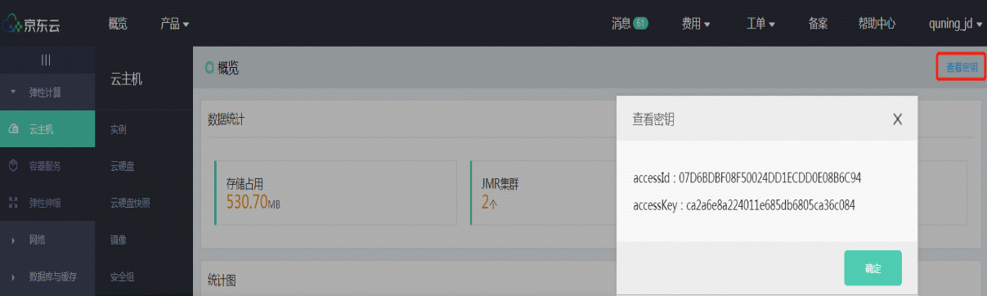

### 2.2 How to Connect Data

The connection of data set is the basis for data collection and data analysis. In the data set catalogue module, the user can select the type of data set for synchronization according to the needs, and finish configuration according to the notification. Successful connection and creation of data set is a precondition of successful synchronization task.

Operations:

Go to **JD Cloud Console > Big Data Infrastructure Services > Data Factory**, to select the data set for connection.

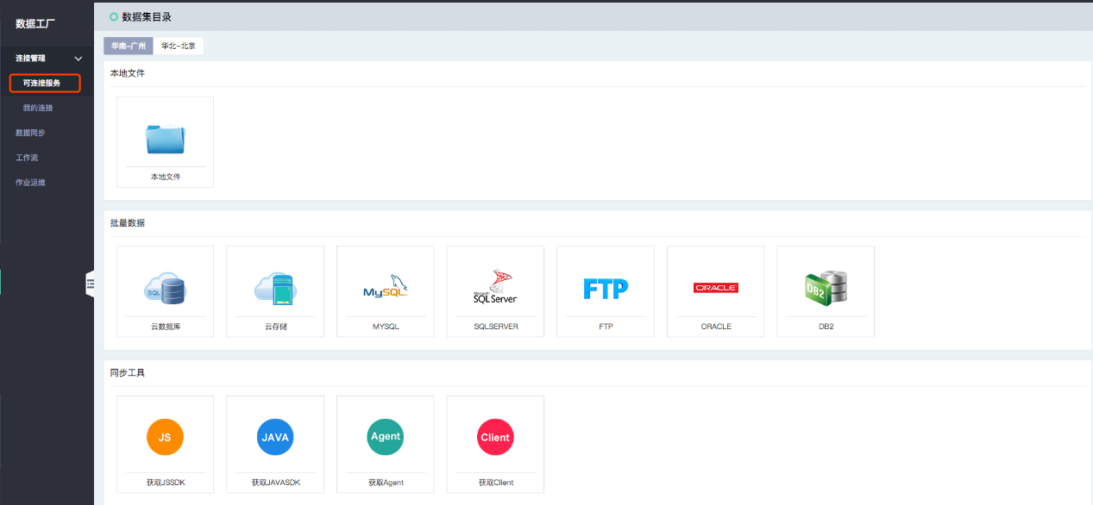

#### 2.2.1 Data and file types supported by Data Factory

The data set currently supported by data services is as follows:

|  |  |  |  |
| --- | --- | --- | --- |
| Classification | Type of data set | Support as the source end | Support as the target end |
| Jcloud | Cloud storage | 🗸 | 🗸 |
| Jcloud | Cloud database | 🗸 | 🗸 |
| Jcloud | Data warehouse | 🗸 | 🗸 |
| Database | SQL Server | 🗸 |  |
| Database | Oracle | 🗸 |  |
| Database | MySQL | 🗸 |  |
| Database | DB2 | 🗸 |  |
| File | CSV | 🗸 |  |
| File | FTP | 🗸 |  |

#### 2.2.2 Connection management - connectable services

Manage the data sets that are connected or imported.

Operations:

**Data Factory > Connection Management > My Connection**, in my connection module, the user can add / manage / modify / delete data set connection. The same connection can be the data source end and data target end of several synchronization tasks according to the needs. If the connection being used is modified or deleted, the synchronization task concerned will fail to run.

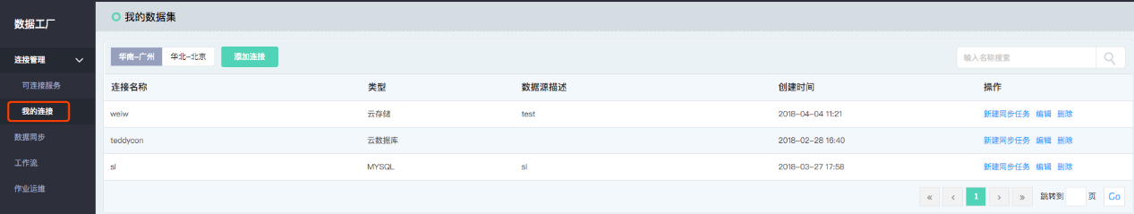

### 2.3 How to Synchronize Data

#### 2.3.1 Objective

Synchronization task is the minimum unit for the user to use the data integration service. Each synchronization task requires the user to configure data source end, data target end and the corresponding synchronization strategy (such as dirty data processing, etc.) By establishment of data synchronization tasks, different data set sources can be transferred to the target end.

#### 2.3.2 Create synchronization task

Operations:

**Data Factory > Data Synchronization**, click “Create” to create a new synchronization task. Enter the name and description of the synchronization task for later identification, monitoring and management of the synchronization task.

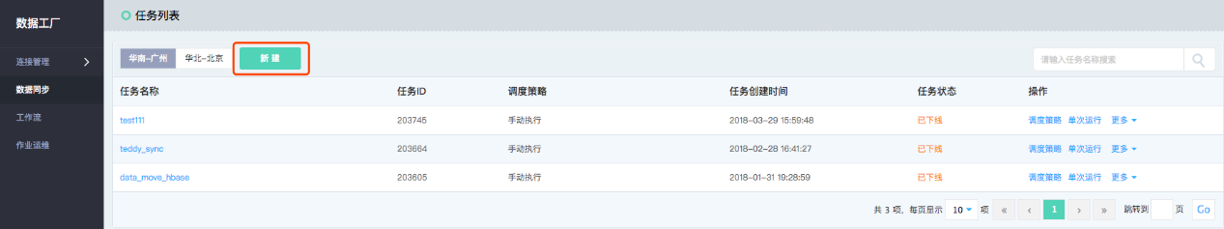

#### 2.3.3 Establish a data source end connection

After clicking “create synchronization task”, configure the data source end and target end. Select “data source end” as the output end of the synchronization task, and select “data target end” as the input end of the synchronization task. By the synchronization task, data will be obtained from the data source end and the data will be written into the data target end according to the rules configured by the user.

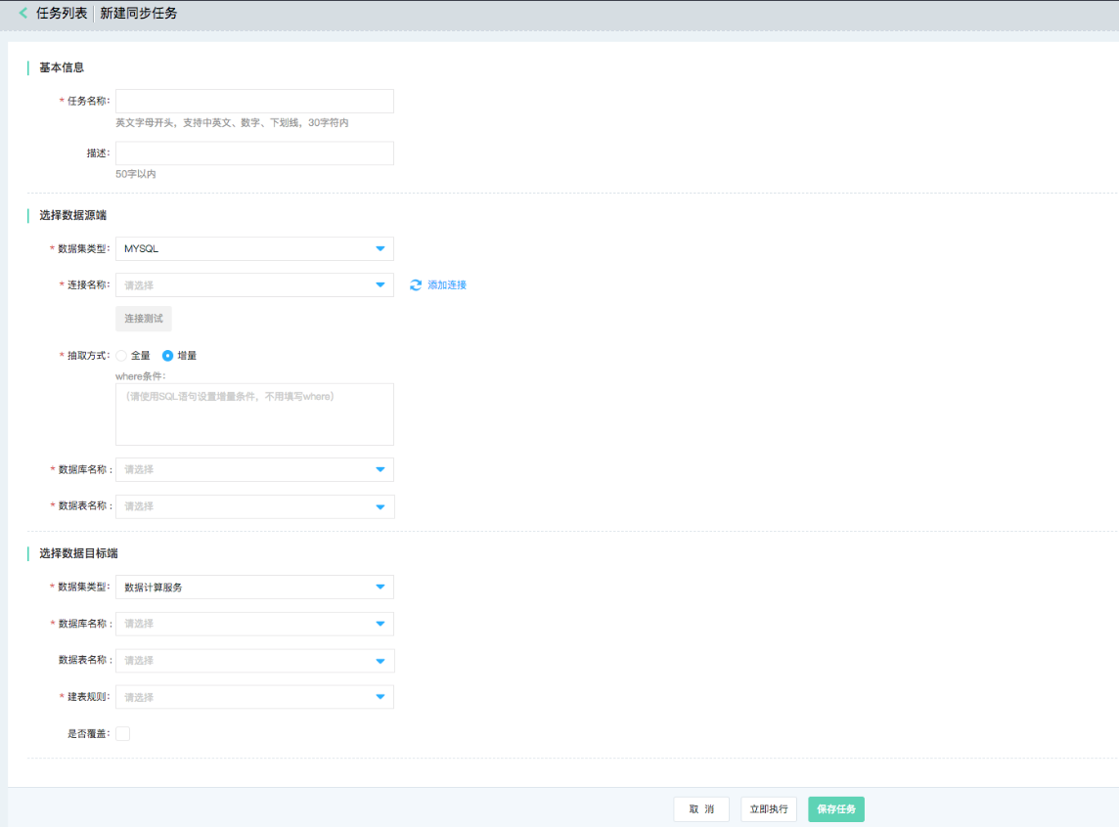

Click “Run Now”, the current synchronization task is saved and performed. You can view the corresponding synchronization task instance and running instance generated in the task list and running history. If currently only this synchronization task is required to be saved, there is no need to save, click “save” and return to the task list.

### 2.4 How to Transport Data

By establishment of periodic data synchronization tasks, periodic data transportation and task management can be realized for rapid data analysis.

Operations:

**Data Factory > Data Synchronization > Scheduling Policy**, select “Single Operation” or “periodic scheduling” for execution frequency, and periodic policy can meet different frequency scheduling by days / weeks / months. When the scheduling policy needs to be adjusted or paused, also process in this module.

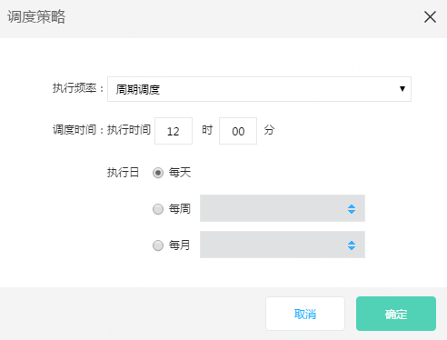

### 2.5 Data Synchronization Task Management

Operations:

**Data Factory > Data Synchronization > Task List**, the user can manage all data synchronization operations in the Data Factory's synchronization task list. The synchronization tasks that need to be modified or go online / downline are also conducted in this module.

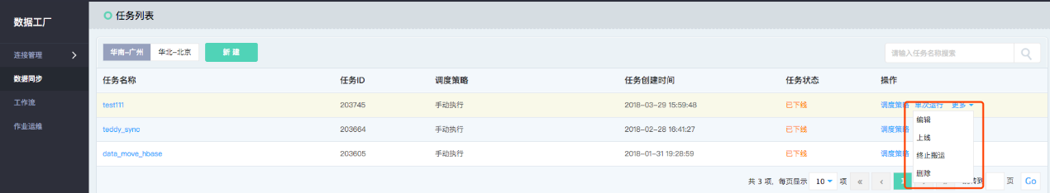

## III. User Guide for Console Operation

### 3.1 Data Factory

Data Factory is a data mobile service product offered by JD Cloud, which can help users to realize the free flow of data. Through the Data Factory, data synchronization among several different data sources between local data sources and cloud data sources and among data sources (including object storage, cloud database, data warehouse, etc.) can be easily realized, and multi-source data analysis and management can be realized.

Synchronization tasks can be created in the Data Factory service to transport data and run according to a specified scheduling policy (daily, weekly, monthly). The module provides task monitoring and alarm functions, and users can easily identify the problem through the detail log and alarm history executed by tasks; at the same time, it provides a fully hosted workflow service to support graphical design data analysis. The data processing and interdependence can be realized by workflow task, which can help users quickly create data processing and analysis jobs and execute them periodically.

For the operation ways for the Data Factory to support data connection / transport data set, please see 2.3.

#### 3.1.1 Function overview

##### 1) Data synchronization

Off-line and batch data synchronization among different data sources;

Support synchronization of data from multiple local and cloud data sources, and support different synchronization strategies such as full synchronization and increment synchronization by the user.

##### 2) Synchronization task scheduling management

Uniformly manage and schedule synchronization tasks;

Formulate the scheduling policy during such different time horizons as day and hour by virtue of the uniform synchronization task management.

##### 3) Monitor alarm

Set the monitor alarm rules for the synchronization task;

Set various alarm policies for data integration with respect to the synchronization tasks at different important grades, letting you know the operating status of the synchronization tasks the first time. Support the user to examine the complete execution log, and record the synchronization tasks for details.

#### 3.1.2 Connection product

Data Factory could match data computing service, streaming data bus, stream computing, and JMR products for combined use.

#### 3.1.3 Definition of terms

##### 1) Data set

Data set in the Data Factory service refers to different data storage instances of data source end or data target end to be appointed when tasks are synchronized. Hence, you must provide access to the data set firstly before the synchronization task is built. The same data set can be the data source ends or data target ends of multiple synchronization tasks.

##### 2) Connectivity of data set

When the user creates the data set, the user fills in the corresponding values for connectivity check according to different types of data set, in order to view the data set service can be accessed successfully. Successful connection of data set is a precondition of successful data synchronization task.

##### 3) Synchronization task

Synchronization task is the minimum unit for the user to use the Data Factory service. Each synchronization task requires the user to configure data source end, data target end and the corresponding synchronization strategy (such as dirty data processing, etc.)

##### 4) Workflow

The workflow implements data processing and interdependence for data in such a manner of graphical design task.

#### 3.1.4 Operation guide

##### 3.1.4.1 Login to console

After login to the **Data Factory console** with the account, the system shows the interface access to the management instance list, as shown in the figure below:

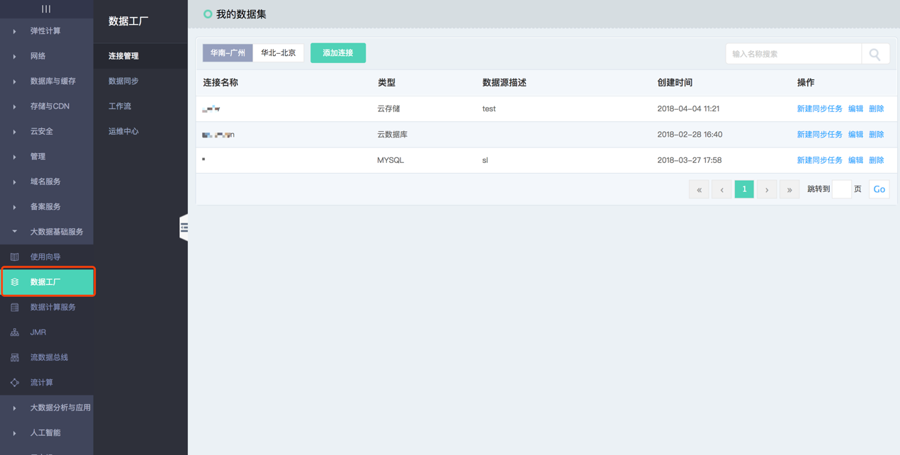

##### 3.1.4.2 Connection management

###### 1) Local file access

Operations:

1. Select regional information about data source and click “local file” for operation:

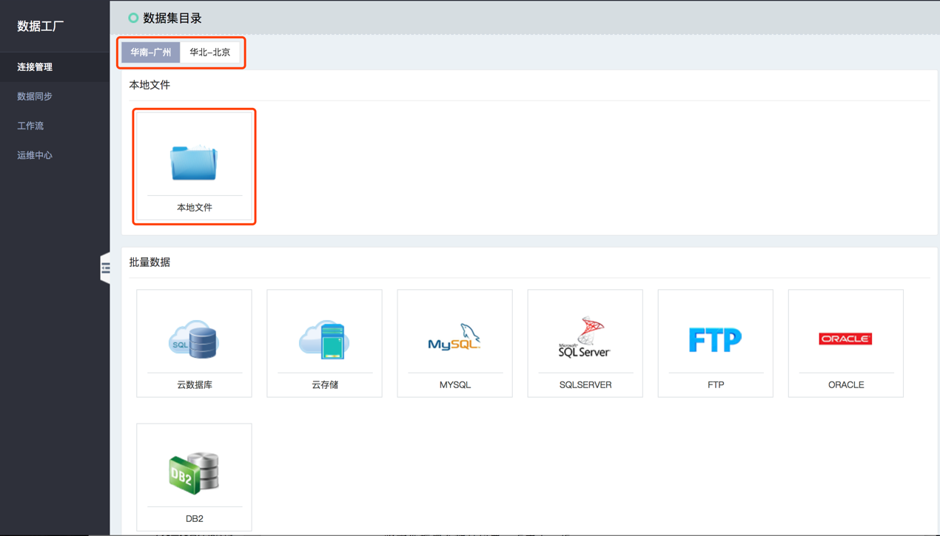

1. For file upgrading, click “Plus” or drag the file to the position of “Plus”, and click “Next”:

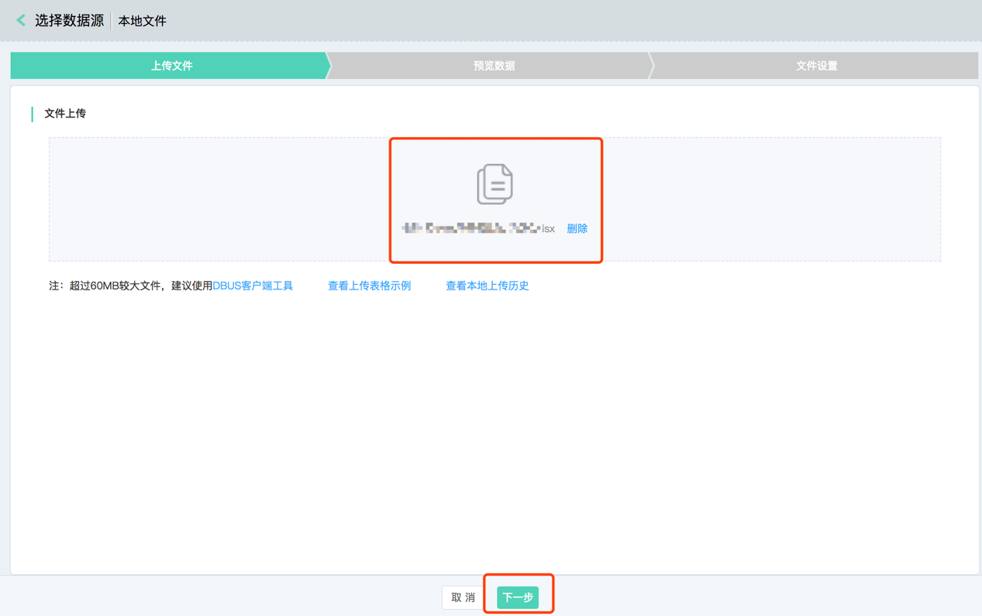

1. Preview data upon operation:

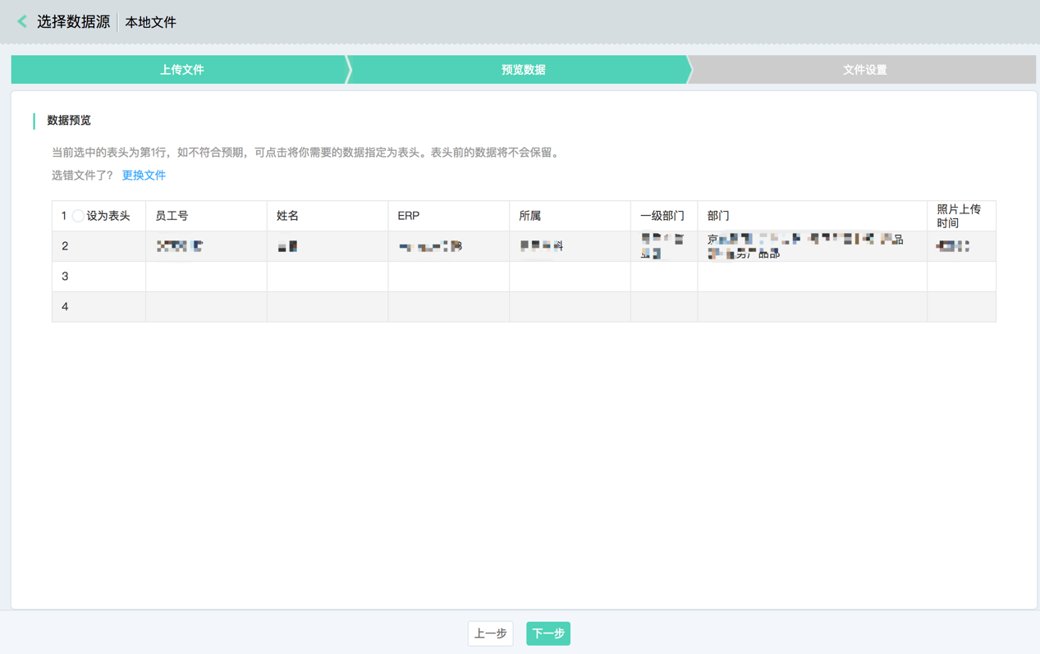

1. Click “Next” for storage setting:

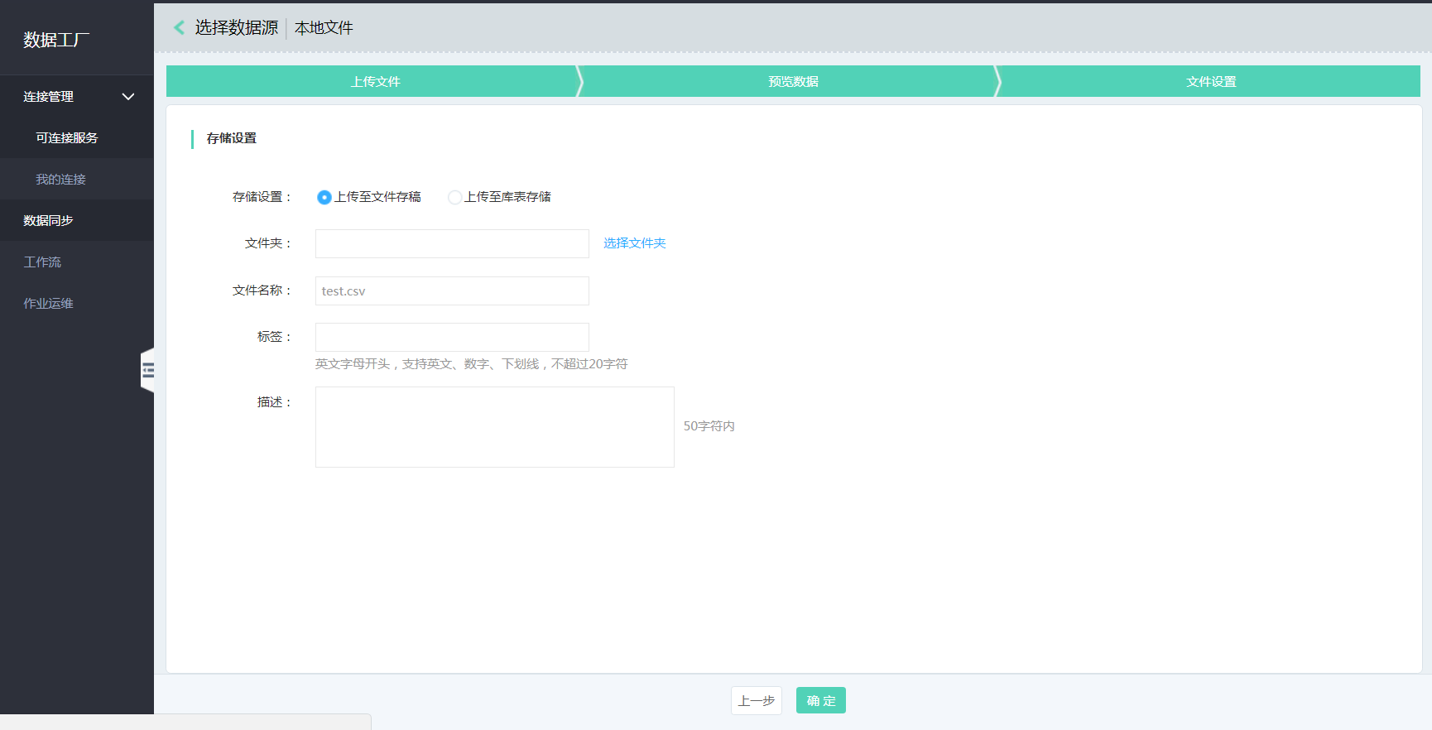

If “upgrading to the storage table for storage” is selected, choose the corresponding database and table, and correspond to source table field and database target table field by virtue of mouse connection.

###### 2) Data source configuration

###### a) Configuration of data source in cloud database

You can configure the synchronization task because the data source in the cloud database provides the ability to read RDS.

**Operation:**

1. Enter the Data Factory, click “connection management”, and select “addition collection”;
2. Choose the data source type “cloud database”;

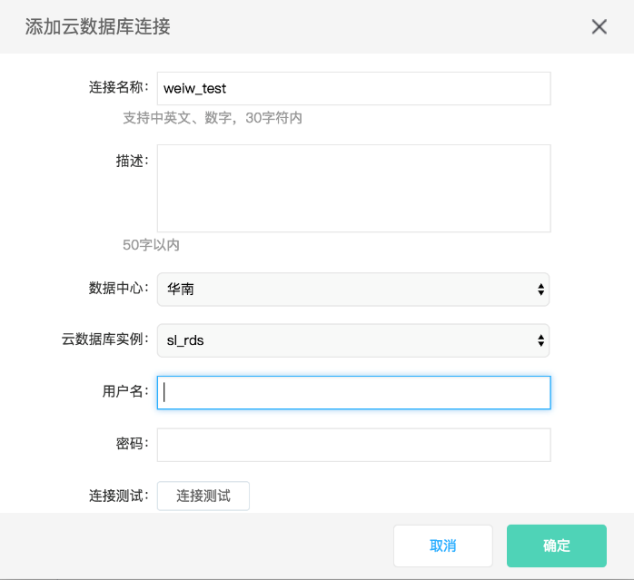

Configuration item description:

* **Connection name:** include Chinese and English letters, digits and underline, with no more than 30 characters;
* **Description:** depict data source simply, with no more than 50 characters;
* **Data center:** choose the region and support “North China” and “South China” now;
* **Cloud database instance:** choose the data source instance name;
* **User Name/password**: user name and password corresponding to the database.

1. Click “connection test”;
2. Click “OK” after the connection test passes.

###### b) Configuration of cloud storage data source

The safe, stable, massive and convenient object storage service (OSS) is provided to the user by JD Cloud.

**Operation:**

1. Enter the Data Factory, click “connection management”, and select “addition collection”;
2. Choose the data source type “cloud storage”;

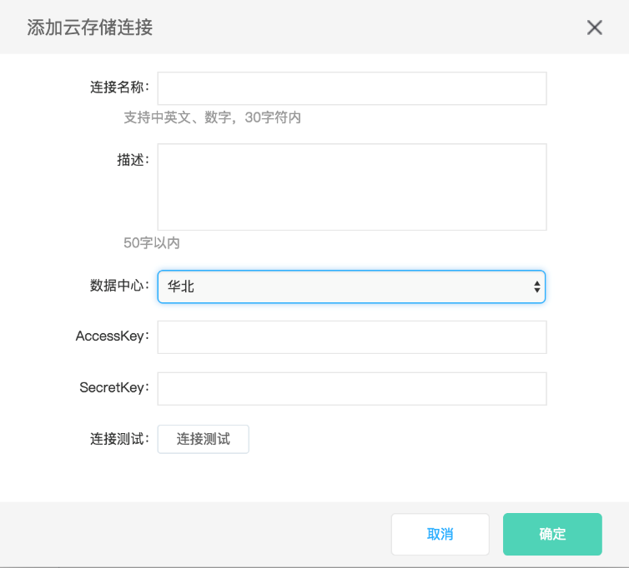

Configuration item description:

* **Connection name:** include Chinese and English letters, digits and underline, with no more than 30 characters;
* **Description:** depict data source simply, with no more than 50 characters;
* **Data center:** choose the region and support “North China” and “South China” now;
* **AccessKey/SecretKey:** view in Access Key management, see 2.1.4;

1. Click “connection test”;
2. Click “OK” after the connection test passes.

###### c) Configuration of MYSQL data source

You can configure the synchronization task because MySQL relational database data source provides the ability to read Mysql.

**Operation:**

1. Enter the Data Factory, click “connection management”, and select “addition collection”;
2. Choose the data source type “MYSQL”;

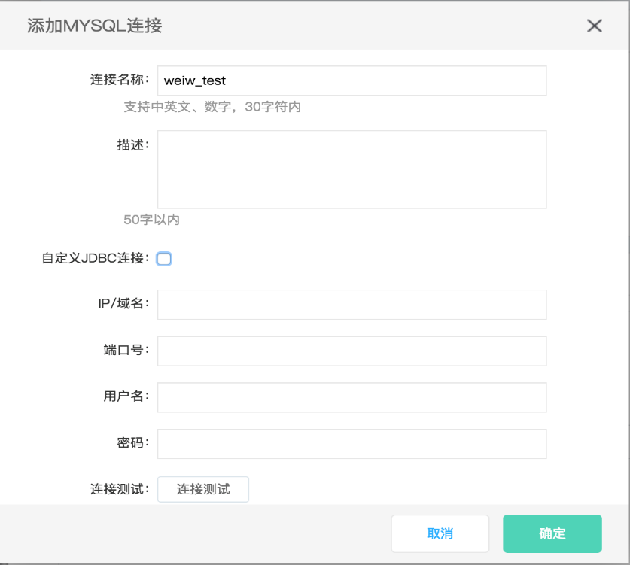

Configuration item description:

* **Connection name:** include Chinese and English letters, digits and underline, with no more than 30 characters;
* **Description:** depict data source simply, with no more than 50 characters;
* **Customized JDBC link**: whether to enable JDBC connection way;
* **IP / domain name**: fill in connection information;
* **Port No.:** fill in connection information;
* **User Name/password**: user name and password corresponding to the database.

1. Click “connection test”;
2. Click “OK” after the connection test passes.

###### d) Configure SQLServer data source

You can configure the synchronization task because SqlServer relational database data source provides the ability to read SqlServer.

**Operation:**

1. Enter the Data Factory, click “connection management”, and select “addition collection”;
2. Choose data source type “SQLSERVER”;

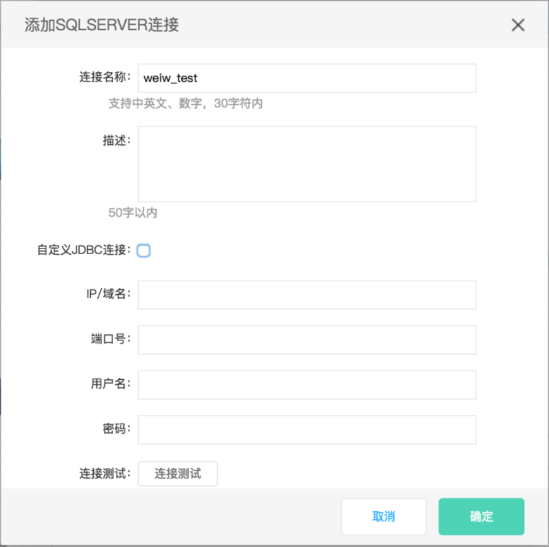

Configuration item description:

* **Connection name:** include Chinese and English letters, digits and underline, with no more than 30 characters;
* **Description:** depict data source simply, with no more than 50 characters;
* **Customized JDBC link**: whether to enable JDBC connection way;
* **IP / domain name**: fill in connection information;
* **Port No.:** fill in connection information;
* **User Name/password**: user name and password corresponding to the database.

1. Click “connection test”;
2. Click “OK” after the connection test passes.

###### e) Configuration of FTP data source

You can configure the synchronization task because FTP data source provides the ability to read FTP.

**Operation:**

1. Enter the Data Factory, click “connection management”, and select “addition collection”;
2. Choose data source type “FTP”;

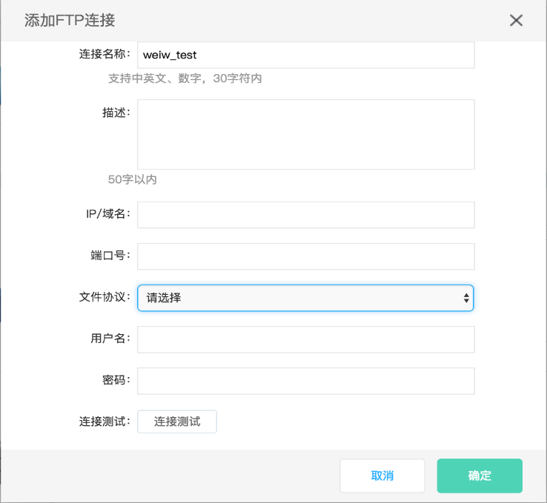

Configuration item description:

* **Connection name:** include Chinese and English letters, digits and underline, with no more than 30 characters;
* **Description:** depict data source simply, with no more than 50 characters;
* **IP / domain name**: fill in connection information;
* **Port No.:** fill in connection information;
* **File protocol**: FTP, SFTP and FTPS are supported for now;
* **User Name/password**: user name and password corresponding to the database.

1. Click “connection test”;
2. Click “OK” after the connection test passes.

###### f) Configuration of Oracle data source

You can configure the synchronization task because Oracle relational database data source provides the ability to read Oracle.

**Operation:**

1. Enter the Data Factory, click “connection management”, and select “addition collection”;
2. Choose data source type “ORACLE”;

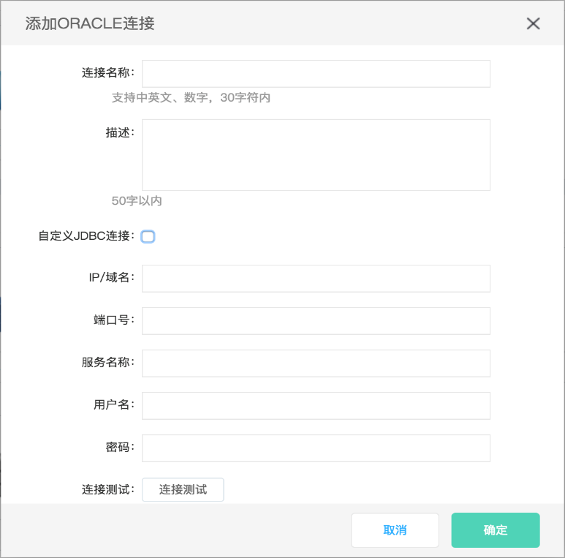

Configuration item description:

* **Connection name:** include Chinese and English letters, digits and underline, with no more than 30 characters;
* **Description:** depict data source simply, with no more than 50 characters;
* **Customized JDBC link**: whether to enable JDBC connection way;
* **IP / domain name**: fill in connection information;
* **Port No.:** fill in connection information;
* **Service name:** name information;
* **User Name/password**: user name and password corresponding to the database.

1. Click “connection test”;
2. Click “OK” after the connection test passes.

###### g) Configuration of DB2 data source

You can configure the synchronization task because DB2 relational database data source provides the ability to read DB2.

**Operation:**

1. Enter the Data Factory, click “connection management”, and select “addition collection”;
2. Choose data source type “DB2”;

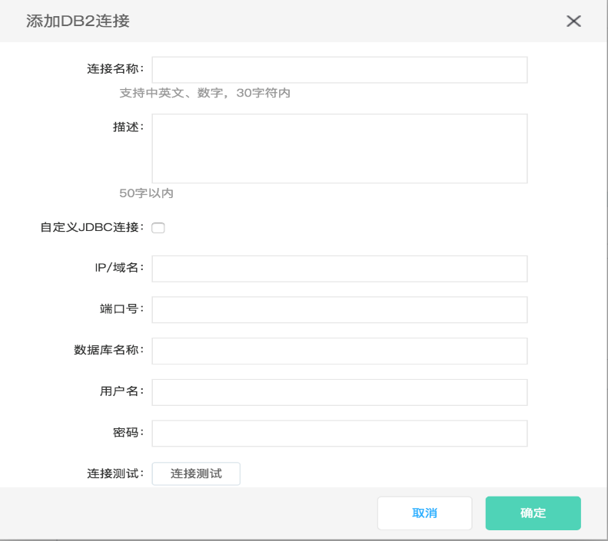

Configuration item description:

* **Connection name:** include Chinese and English letters, digits and underline, with no more than 30 characters;
* **Description:** depict data source simply, with no more than 50 characters;
* **Customized JDBC link**: whether to enable JDBC connection way;
* **IP / domain name**: fill in connection information;
* **Port No.:** fill in connection information;
* **Database name:** name information;
* **User Name/password**: user name and password corresponding to the database.

1. Click “connection test”;
2. Click “OK” after the connection test passes.

##### 3.1.4.3 Data synchronization

###### 1) Create synchronization task

Operations:

1. Click “Create new” button in the data synchronization task list page:

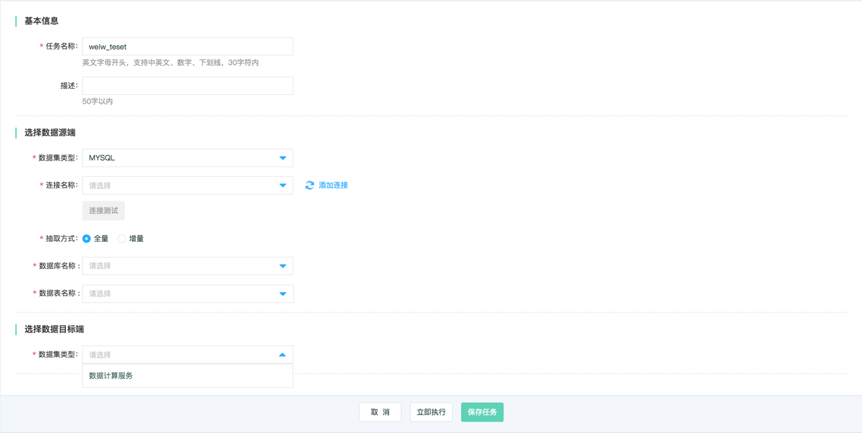

1. Data sources supported now include:

* Data source end includes: cloud database, cloud storage, MYSQL, SQLSERVER, ORACLE, FTP, DB2, and data computing service;
* Data target end includes: data computing service, MYSQL, SQLSERVER, FTP, RDS;

Its handling capability is shown in the table below:

|  |  |  |  |
| --- | --- | --- | --- |
| Classification of data source | Data source | As the source end | As the target end |
| File system | Local file | ✓ |  |
| Relational database | Cloud database MySQL | ✓ | ✓ |
| Cloud database SQL Server | ✓ | ✓ |
| MySQL | ✓ | ✓ |
| SQL Server | ✓ | ✓ |
| Oracle | ✓ |  |
| DB2 | ✓ |  |
| Big data storage | Data computing service (DCS) | ✓ | ✓ |
| Semi-structured storage | OSS | ✓ |  |
| FTP | ✓ | ✓ |
| SFTP | ✓ | ✓ |
| FTPS | ✓ | ✓ |
| NoSQL | Redis (Coming soon） |  |  |
| Message queue | JCQ (Coming soon） |  |  |

###### 2) Operation and maintenance of synchronization task

The list page is shown in the figure below:

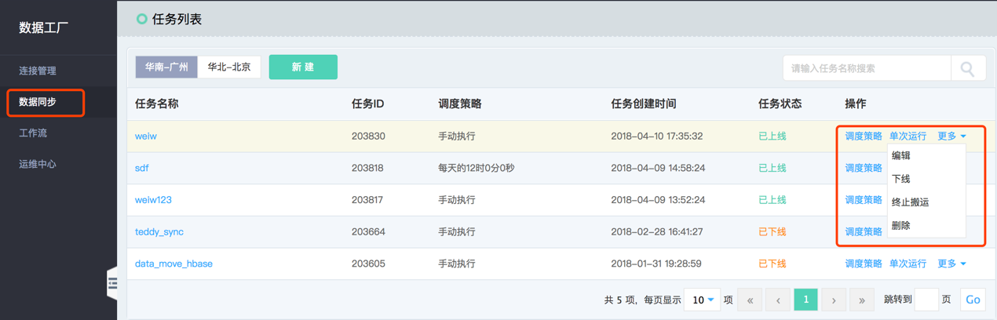

* Task details: click the task name, enter the task details; and meanwhile, view the execution history;
* Scheduling policy: support single timed execution and periodic execution (day, week and month);
* Single operation: carry out single task operation in real time;
* Edit: modify the task;
* Off-line: allow the task to be off-line and prohibit operation;
* Handling termination: stop operation of the task in execution;
* Delete: delete the task.

##### 3.1.4.4 Workflow

###### 1) Create workflow

Precondition: need to make sure that you create the datasheet in the “**data computing service - data warehouse**” and upgrade data; create the result list because the workflow operation result is output to the data warehouse.

**Operation:**

1. Choose the computing node region;
2. Click “Create definition” to create the workflow:

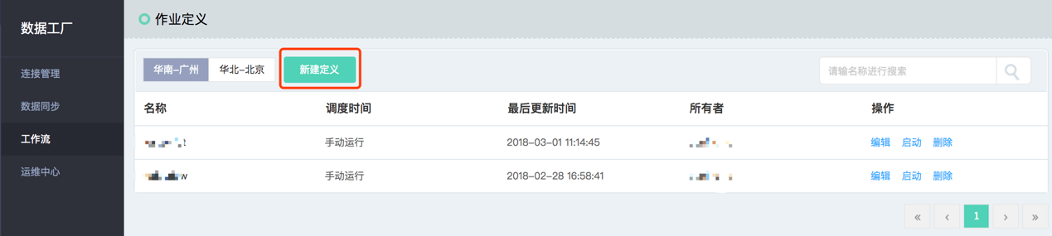

1. Set the spark task:

Drag SPARK module to the center area; add spark task name, description, selection type and complemented script. Connect the workflow with the mouse upon saving when script type supports sql, python and scala.

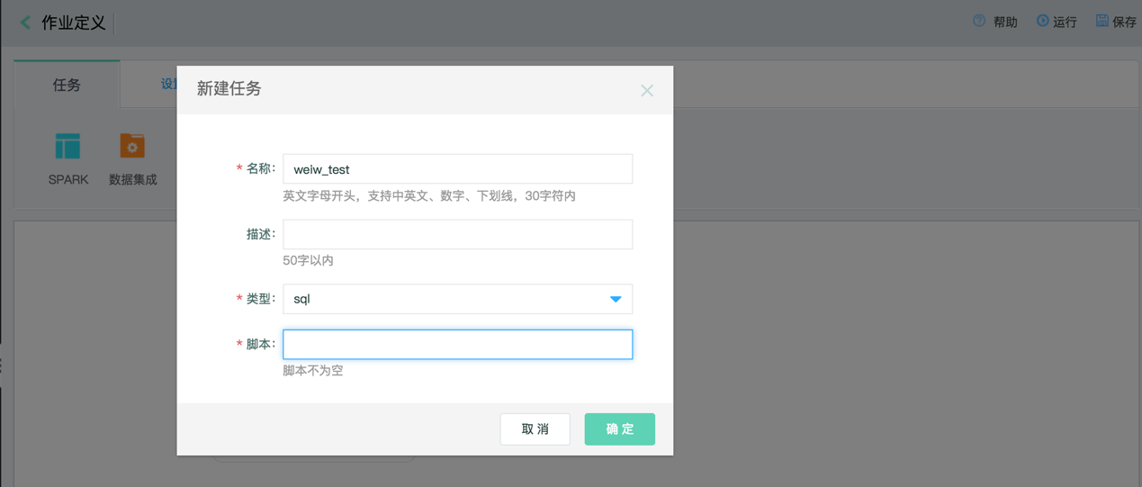

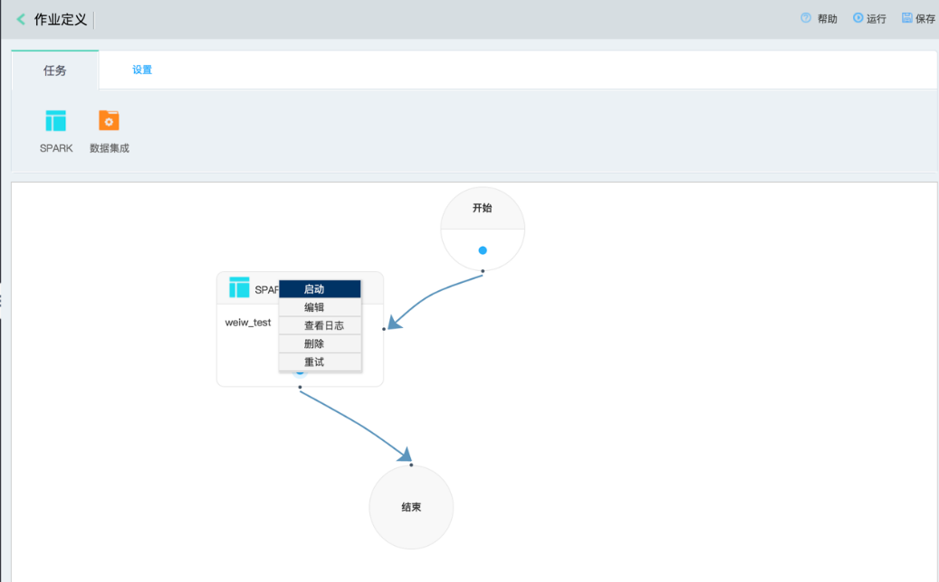

Click the SPARK task with the right key to start, edit, delete and retry the task and examine the log.

1. Set data integration task

Drag data integration to the center of screen; pop out the edit menu for data synchronization.

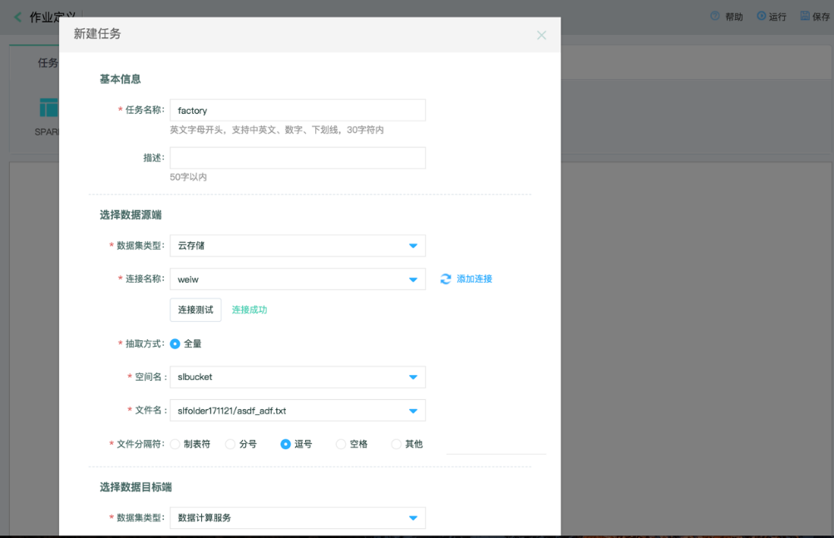

Click “OK” key for save:

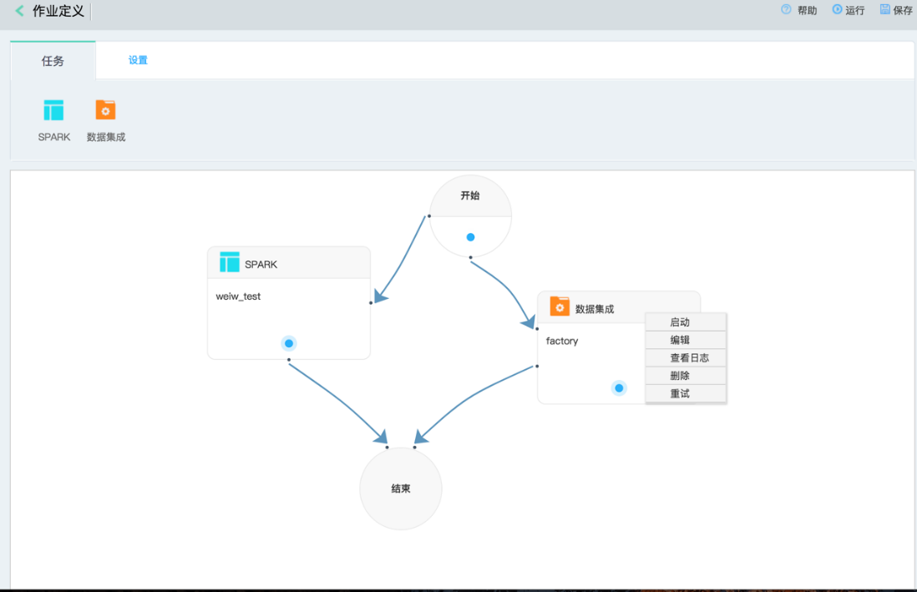

Click the data integration task with the right key to start, edit, delete and retry the task and examine the log.

1. Choose “set” Tab page to save the workflow, and set the execution policy according to demands:

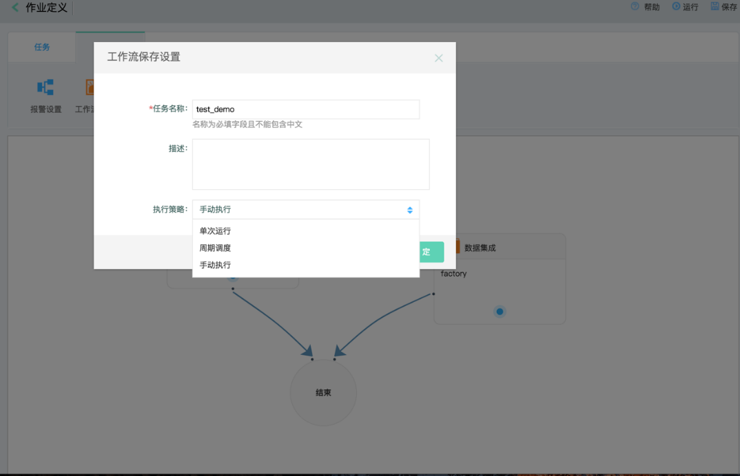

1. Set alarm information:

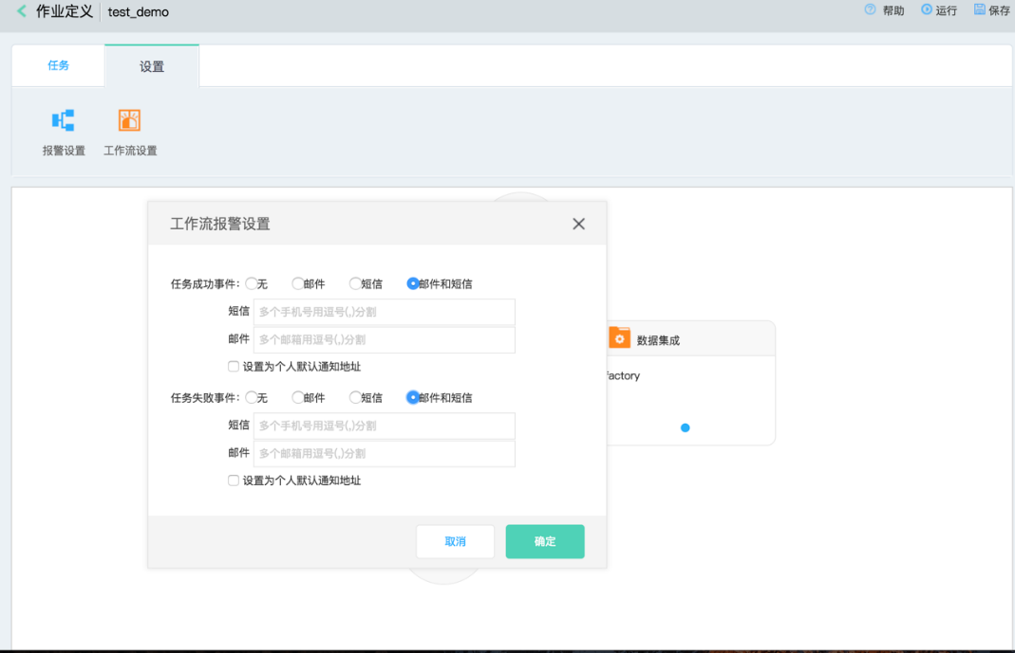

###### 2) Workflow operation and maintenance

The list page is shown as below:

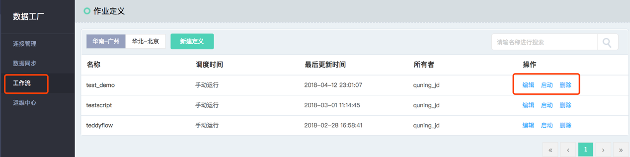

* Edit: modify workflow;
* Start: start workflow;
* Delete: delete workflow.

##### 3.1.4.5 Operation and maintenance center

View execution of the workflow, and search its name:

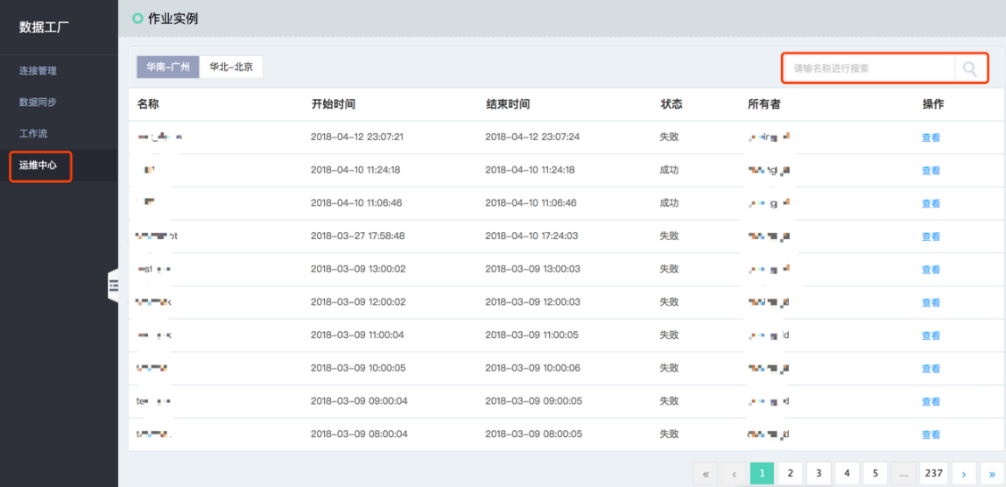

### 3.2 Data Computing Service

JD Cloud data computing service (DCS) is a fully-hostedcloud database service with low cost. The data computing service provides out-of-the-box data management, flexible computing source, open data interface and fine-grained permission system, helping the user establish the enterprise level data analysis platform and focusing on the work releasing data value constantly.

#### 3.2.1 Function overview

##### 1) Massive data computing

Provide the enterprise level data warehouse solution and SQL/PySpark and other computing abilities to meet massive data ETL and interactive inquiry demand.

##### Fully hosting and out-of-box use

Analyze data quickly by virtue of simple setting; build the cluster bottom layer and fully-hosted operation and maintenance.

##### Task development

Provide functions of task development, function customization and task scheduling; and support the developer for task development via WEB/IDE/CLI/SDK.

##### User permission management

Stipulate security mechanism for data storage and access; provide the multi-dimensional permission view system to data operation permission.

#### 3.2.2 Connection product

Data computing service could match Data Factory, streaming data bus, stream computing and JMR product for combined use.

#### 3.2.3 Data source configuration

##### 3.2.3.1 Data uploading

Data computing service supports uniform storage of structured and unstructured data. It is the fastest way to import data into the data computing service by virtue of [using Data Factory](https://www.jcloud.com/products/dataintegration).

##### 3.2.3.2 Library list management

###### 1) Create database

Operations:

1. Choose library list management by the page navigation, and click “create new database” button;

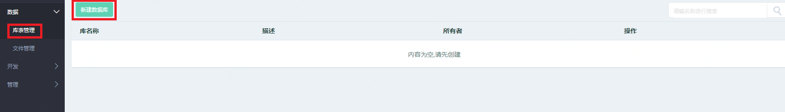

1. Input database name and description in the “create new database” window; create the database upon clicking “OK”;

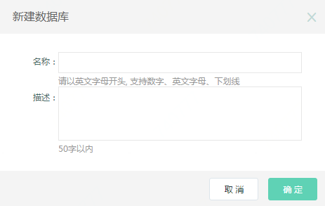

The database name needs to begin with English letters, supporting digits, English letters and underline, with length of 64 characters.

1. Click the view icon operated by the database to show such basic information as database name, list quantity, memory space and owner and description;
2. Click delete icon operated by the database to make a notification whether to delete the database; after the delete icon is clicked, delete the database; only when the database is empty and no datasheet is provided, the database could be deleted.

###### 2) Create datasheet

Operations:

1. Click the database list by page navigation; click the database name in the datasheet page to enter the database list page;

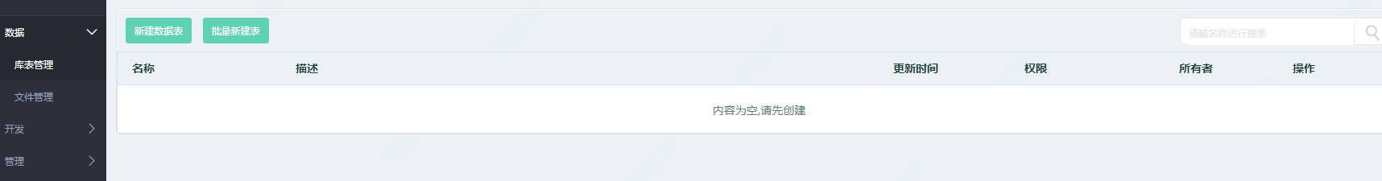

1. Click “create new datasheet” button at the right side of the database list page;

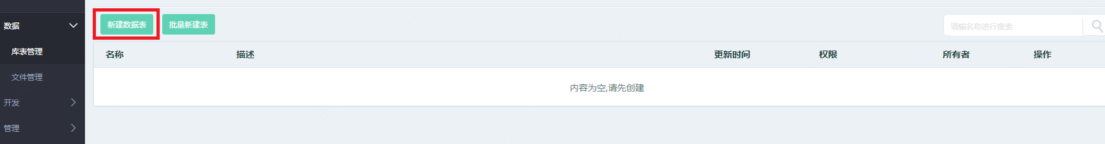

1. Fill in all configuration items of basic information in the created list page; finish creation upon clicking “OK”.

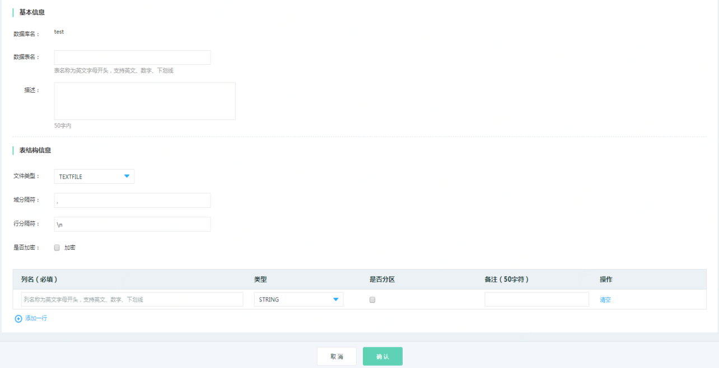

Notes:

* The datasheet name only supports English letters, digits and underline.
* The datasheet name needs to begin with English letters.

###### 3) Upload data

Operations:

1. Click “Batch create list” button at the right side of the datasheet list page;

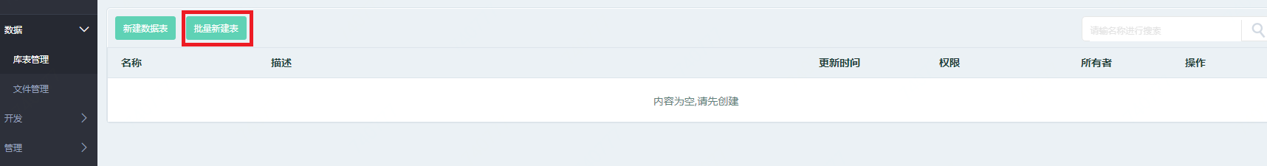

1. Click “Choose file” to choose the local data file to be uploaded; choose the option “Replace current data” according to demands; upload new data to the list by default. Remove original data in the list after “Replace current data” is chosen;

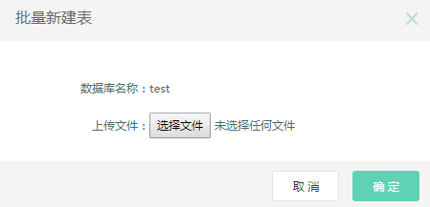

##### 3.2.3.3 File management

###### 1) Create new folder

Operations:

1. Click file management by page navigation;

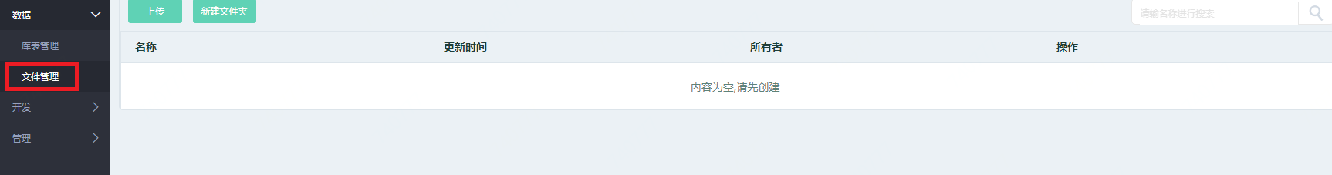

1. Click “Create new folder” button”;

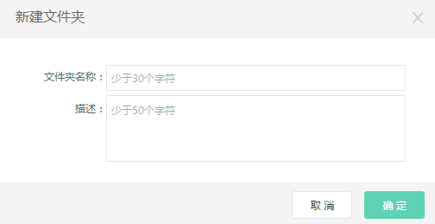

1. Click “OK” for creation after the folder name is filled in.

Notes:

* The folder name can only include Chinese and English words, digits and underline.

###### 2) Upload file

Operations:

1. Click “Upload” button in the page;

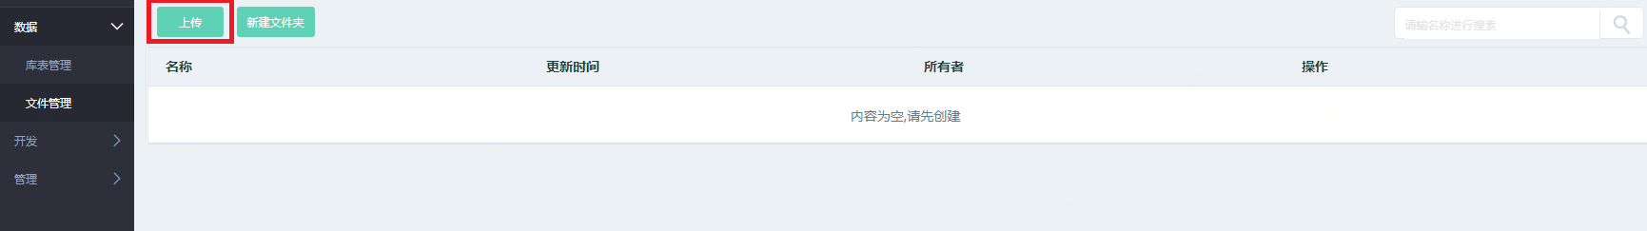

1. Click “Choose file” in the pop-up window; choose the file to be locally uploaded; click “Upload” for uploading.

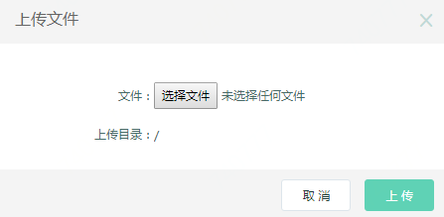

##### 3.2.3.2 Task development

Data computing service supports ANSI-SQL/PySpark to analyze structured and unstructured data now. Switch languages with %SQL and %PySpark.

###### 1) Create development task

Operations:

1. Choose task development page by page navigation;

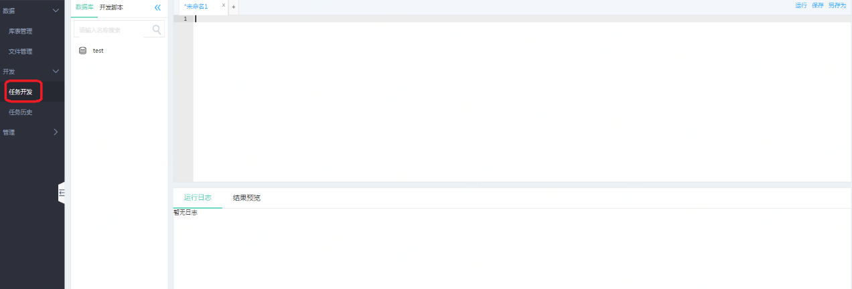

1. Input SQL sentence to be executed; respectively click “run”, “save”, “save as” buttons for related operation;
2. Inquire related SQL running logs and result preview by virtue of page;

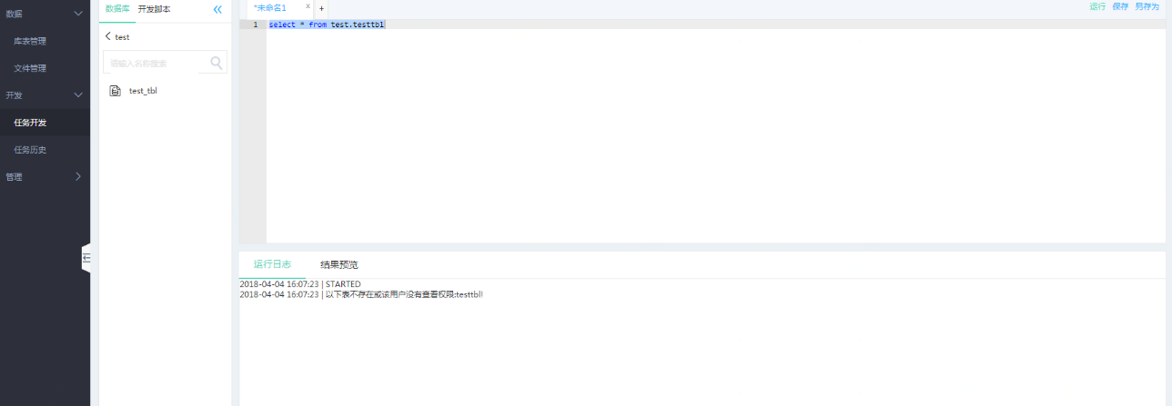

1. Perform “Edit”, “Rename” and “Delete” for the created script through the development script page;

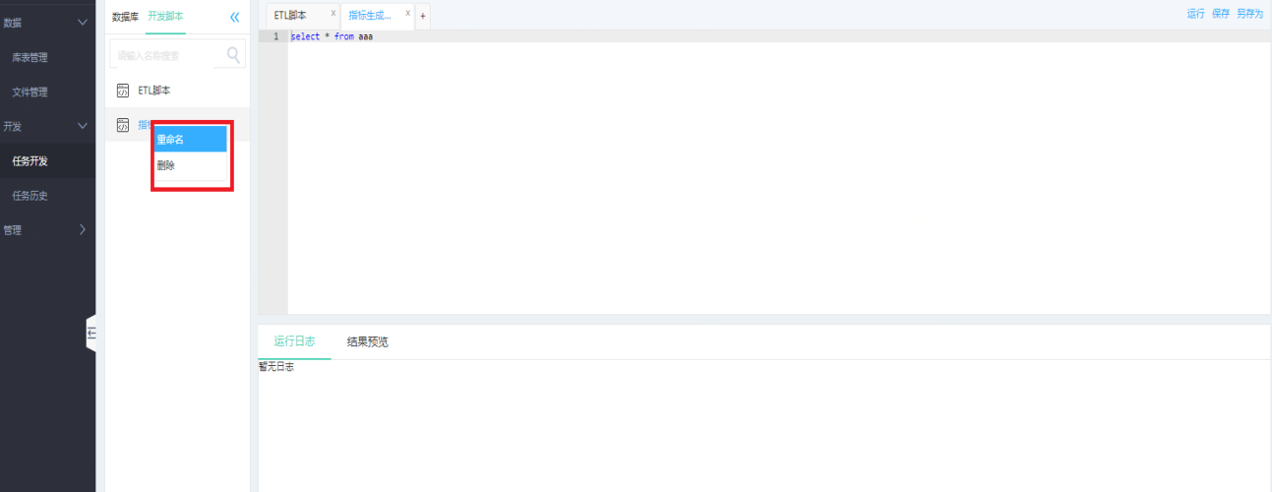

1. Search the database list in task development.

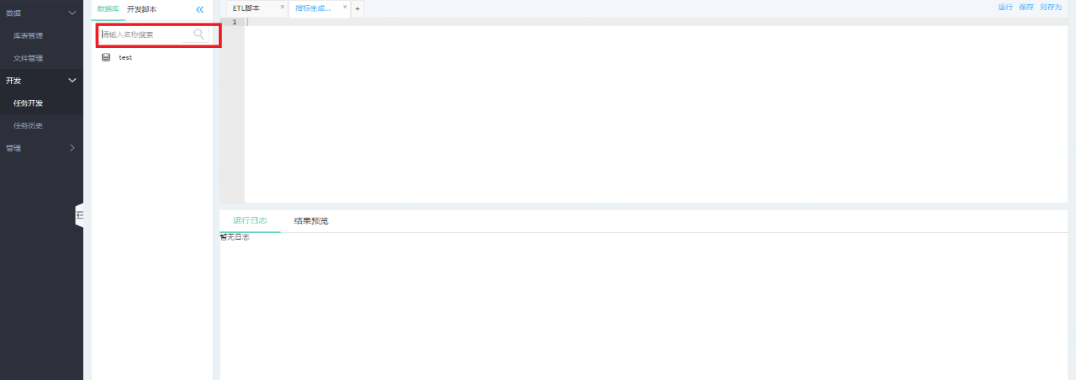

##### 3.2.3.3 Job history

Operations:

1. Choose the task history page to inquire the related task execution status and execution time by page navigation;

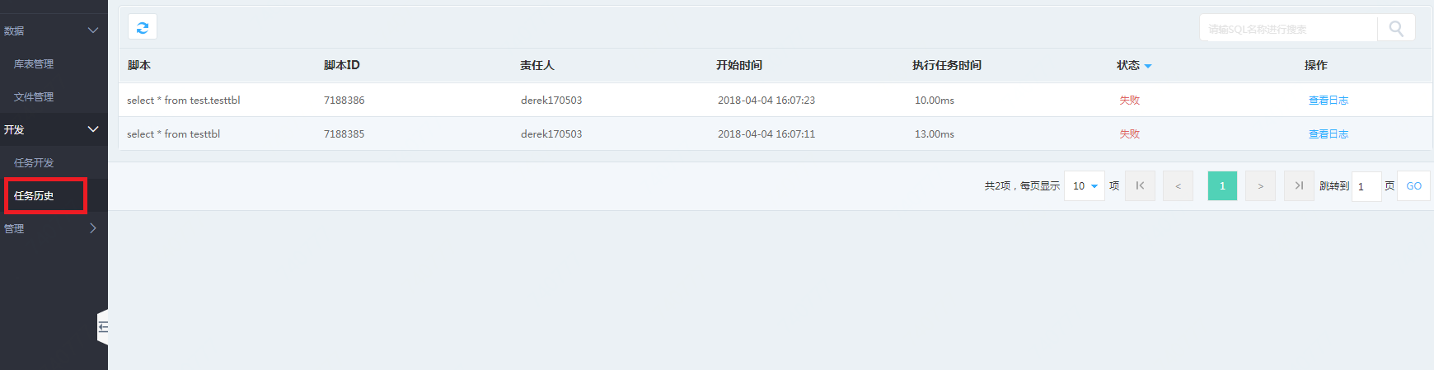

1. Click “Search Log” to enter the task execution log details.

##### 3.2.3.3 User management

###### 1) Create user

Operations:

1. Choose user management to enter the user management page by page navigation;

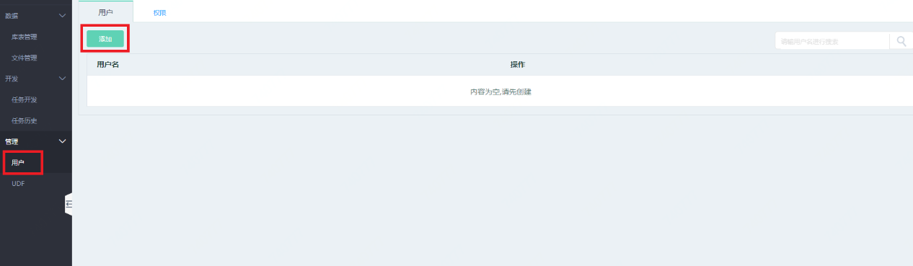

1. Click “add” button to input the user name; click “OK” for addition by the user.

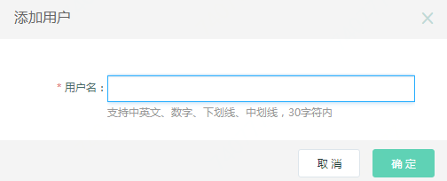

###### 2) Delete the user

Operations:

1. Choose user management by page navigation to enter user management page, and click “delete” button;

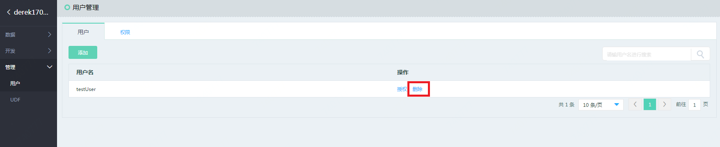

1. Click “delete” OK button to realize user’s deletion according to the notification.

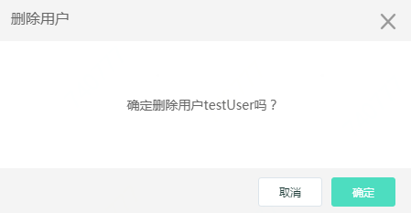

##### 3.2.3.4 Permission management

###### 1) Library list authorization

Operations:

1. Enter user management page by page navigation;

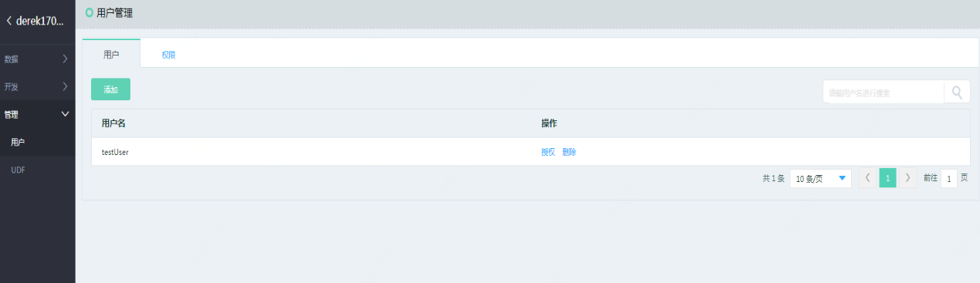

1. Choose user, and click “Authorize” button to authorize the user;

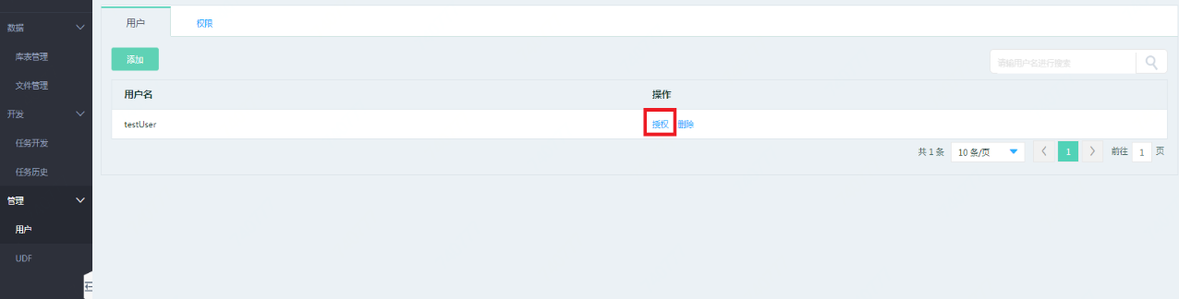

1. Choose the related library to award the user such different permissions as “select”, “createTable” and “dropDatabase”; click “OK” to authorize library permission;

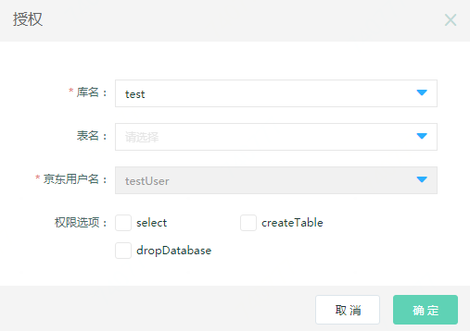

1. Choose the related sheet to award the user such different permissions as “select”, “alter”, “insert” and “drop”; click “OK” to authorize sheet permission.

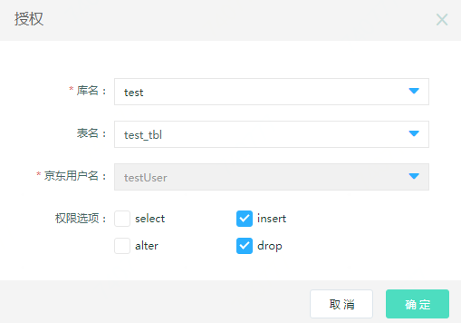

##### 3.2.3.5 UDF function

Data computing service supports user customized UDF function. UDF use instance is as follows:

1. Choose UDF management by virtue of page navigation;

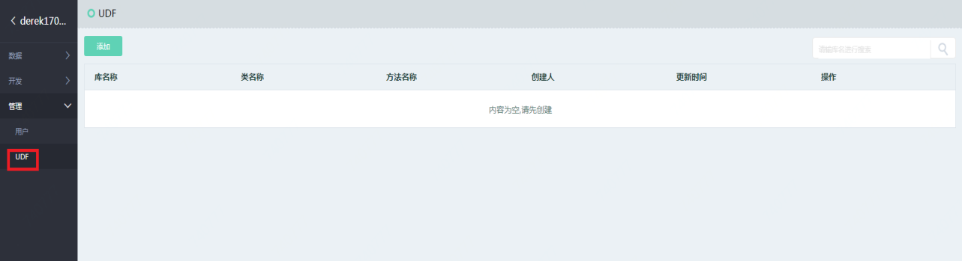

1. Click “Add” button; input library and method names; upload UDF package and package name for UDF addition;

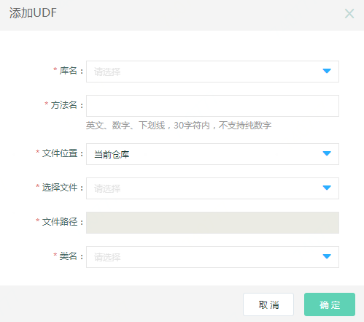

1. Click “Modify” button to modify the related UDF contents;

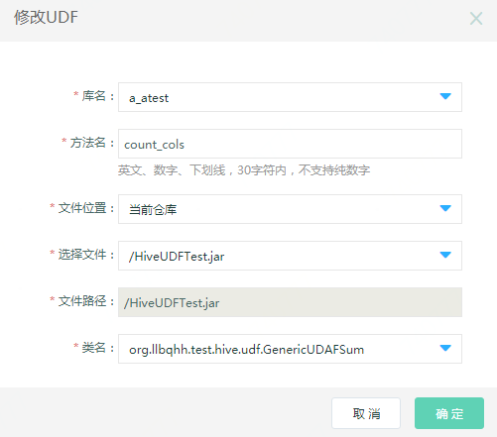

1. Enter the job development page by page navigation; use the uploaded UDF function for task execution.

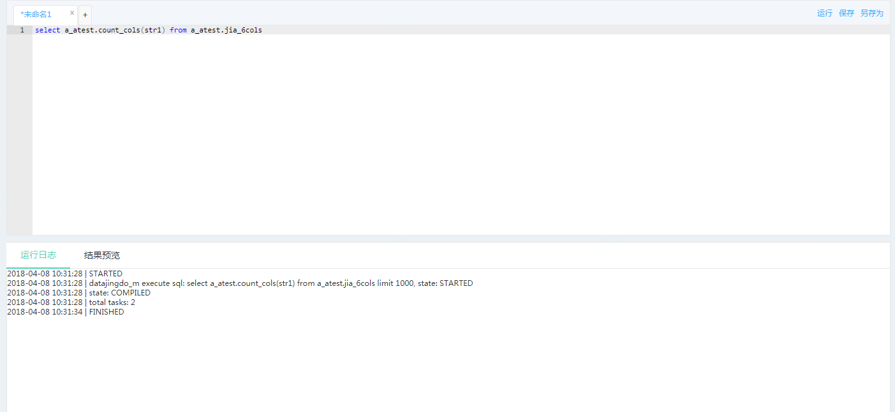

##### 3.2.3.5 Built-in function

Data computing service supports a variety of Hive supported functions, such as math, type conversion, date, data encryption, mixing and aggregate, and built-in table generation. For more details, see built-in function sequence in the Web help file: <https://www.jcloud.com/help/detail/1815/isCatalog/1>

### 3.3 Streaming Data Bus

#### 3.3.1 Function overview

Streaming data bus is a kind of expandable and distributed information service facing with high throughput in the big data scene, providing low-delay message issue and subscription functions, and helping the user quickly build streaming data analysis and application.

The streaming data bus can receive and process millions of messages, and store and process data sent to the streaming data bus by distributed software and equipment. Streaming data bus could be served as a data service entrance for big data on account of providing release and subscription functions with low delay and high scale. Data collected in the streaming data bus could be applied by the downstream service for consumption, for instance, it is provided for real-time data processing by the stream computing product. In the meanwhile, data stored in the streaming data bus could be stored to JD Cloud storage and data warehouse persistently for future analysis.

##### 1) Auto scaling

It can adjust its message processing capacity rapidly and flexibly according to service scale.

##### 2) Easy access

Provide SDK/Agent and other means to quickly access to data.

##### 3) Easy integration

Users can quickly build the real-time analysis application through the integration with the products of stream computing.

##### 4) Auto filing

Provide the data filing function to store data to cloud storage and data warehouse persistently.

##### 5) Usability and user experience

The system mainly provides visual interface maintenance, friendly interface operation and clear function for user use and maintenance.

#### 3.3.2 Connection product

Streaming data bus could match data computing service, stream computing, and BI report form and large-screen product for use.

#### 3.3.3 Operation guide

##### 3.3.3.1 Create subject

###### 1) Make preparations

Register JD Cloud account firstly before the streaming data bus service is applied, see 2.1.

###### 2) Create subject

Operations:

1. Log in WEB console to enter “Subject management” page of the streaming data bus; click “Create new subject”;

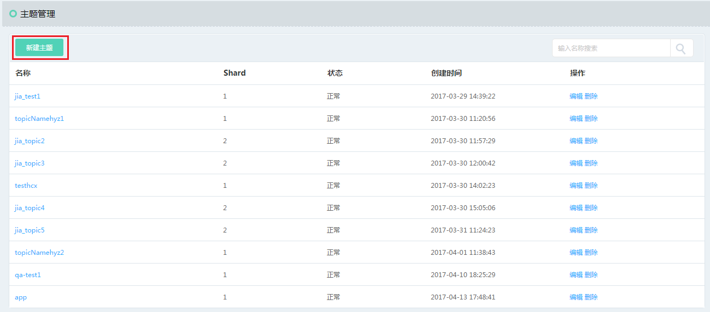

1. Fill in basic information about the subject; click “OK” for subject creation;

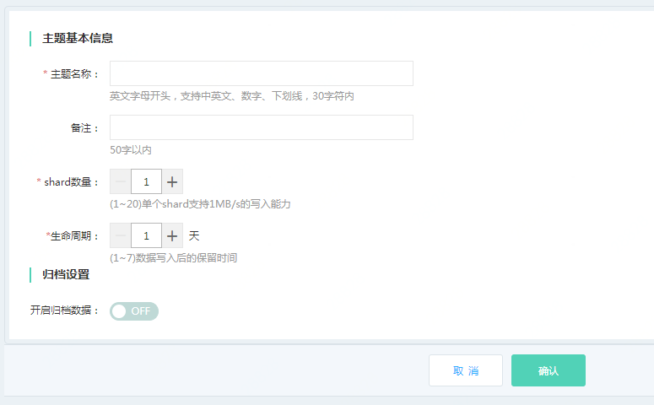

Terminology

* Shard: data processing ability: one shard corresponds to writing 1MB/s or 1000 data and reading 2MB/s data;
* Life cycle: data could be stored in the streaming data bus for 1-7 days.

##### 3.3.3.2 Data archiving

Data access to streaming bus could be saved for 7 days longest. If you need to save data permanently, you must start archiving function and save the data to the place where you want to save persistently.

Operations:

1. Click to edit or create new subject

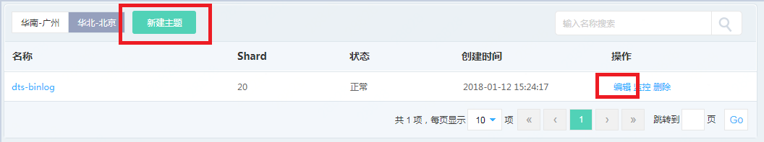

1. Open “Enable archiving data”

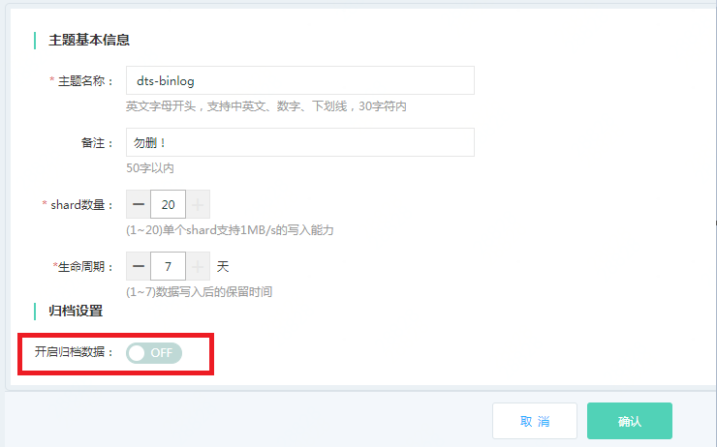

1. Configuration archiving information

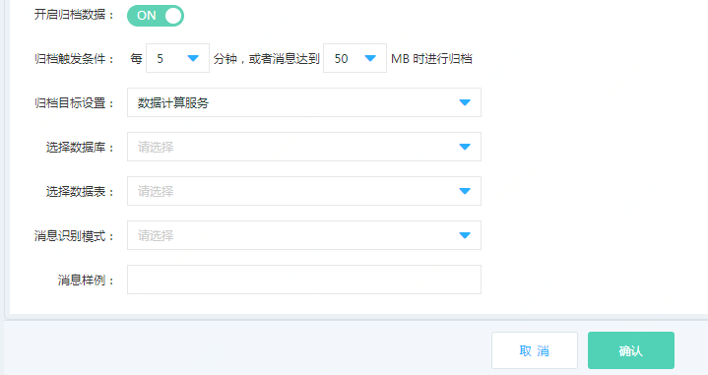

Archiving target setting: archive data to the destination, for instance, data computing service, cloud storage.   
You need to choose “Database” and “Datasheet” if data computing service is chosen.

Message identification mode

1. Delimiter recognition schema: you could stipulate data delimiter for the program to analyze the message.
2. JSON recognition schema: system will automatically recognize json file for analysis.
3. Message style:

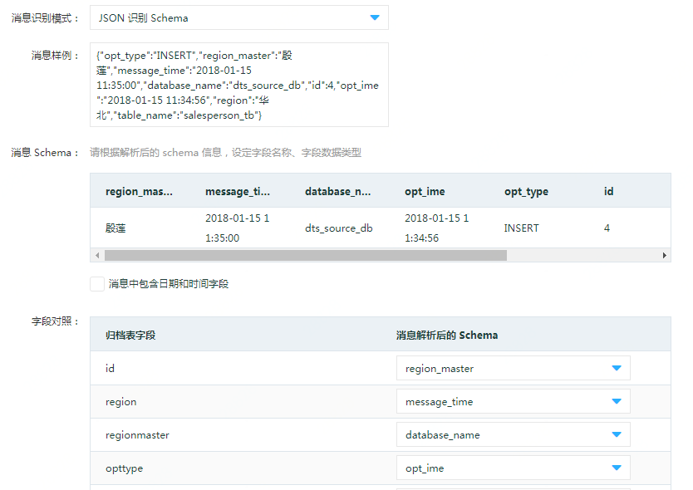

After the message sample is input, the system will recognize schema according to your input delimiter. You need to carry out correspondence mapping for the analyzed archiving field and field in the target end library list in field contrast.

Click “OK” for archiving setting after the mapping relation is configured.

##### 3.3.3.3 Access control

User needs personal identification and authentication before accessing to streaming data bus via the application program, including the related information as follows:

1. Access address of streaming data bus:

1. Public IP address:

South China: [http://streamhub-gw.jcloud.com](http://streamhub-gw.jcloud.com/)

North China: [http://hb-streamhub-gw.jcloud.com](http://hb-streamhub-gw.jcloud.com/)

(2) Private IP: streamhub-gw-inner.jcloud.com

2. accessKey and secretKey

See 2.1.4 for key view method.

##### 3.3.3.4 SDK introduction

Streaming data bus supports the user to write and read data by virtue of SDK, and temporarily support JAVA language SDK, with the specific use methods as follows:

**1. Download SDK**

<https://xdata.jdcloud.com/map/spsdownload/downLoadJavaSDK.action>

**2. Install SDK**

Decompress the compressed file downloaded, and then introduce the jar package into the item for development by referring to the following DEMO program.

**3) Data writing**

(1) StreamHubUpload

The modes to create StreamHubUpload include asynchronous call and customized call.

1. **Asynchronous call mode**

Parameter description:

accessKey: your access key

secretKey: your secret key

topicName: upload the corresponding subject name of data

StreamHubUpload (String accessKey, StringsecretKey, String topicName)

1. **Customized call mode**

Parameter description:

accessKey: your access key

secretKey: your secret key

topicName: upload the corresponding subject name of data

asynchronousfalse: true

StreamHubUpload (String accessKey, StringsecretKey, String topicName, Boolean asynchronous )

Code sample:

|  |
| --- |
| String endpoint = "http://streamhub-gw.jcloud.com";  String accessKey = "Your AccessKey";  String accessScrect = "Your AccessScrect";  String topicName = " Your TopicName";  StreamHubUpload  streamingHubUpload = **new** StreamHubUpload (accessKey,  accessScrect, topicName, endpoint); |

(2) Create upload data object

|  |
| --- |
| String msg = "单条消息";  Entity entity = **new** Entity ();  entity.setKey ("KEY：");  entity.setValue ("VALUE：" + msg); |

(3) Call uploading method

Streaming process provides two data writing ways, including single uploading and multiple uploading.

1. **Single uploading**

Record and write data streams separately include two methods:

Specified partition uploading method: putStreamRecord (Entity, Partition)

Unspecified partition uploading method: putStreamRecoredNoPartiton (Entity)

1. **Multiple uploading**

Record and write data streams in batches include two methods:

Unspecified partition uploading method: putStreamRecords (List, Partition)

Unspecified partition uploading method: putStreamRecordsNoPartiton (List)

|  |
| --- |
| String msg = "单条消息";  Entity entity = **new** Entity ();  entity.setKey ("KEY：");  entity.setValue ("VALUE：" + msg);  String recordId =  streamingHubUpload.putStreamRecord (entity, 1);  System.**out**.println ("upload data result : " +  recordId);  List entities = **new** ArrayList ();  Entity entity1 = **null**;  **for** (**int** i  = 0; i < 10; i++) {  entity1 = **new** Entity();  entity1.setKey ("批量消息KEY:" + i);  entity1.setValue ("批量消息VALUE:" + i);  entities.add (entity1);  }  String recordIds =  streamingHubUpload.putStreamRecords (entities, 1);  System.**out**.println ("upload data result : " +  recordIds); |

(4) Return result description

|  |  |
| --- | --- |
| Parameter | Parameter description |
| result | true: upload successfully | false: fail to upload |
| message | Upload return information |
| code | Upload information code |

**4. Data reading**

(1) Create StreamHubFetch

Parameter description:

accessKey : your access key

secretKey: your secret key

topicName: write the corresponding subject name of data

StreamHubFetch(String accessKey,String secretKey, String topicName)

Code sample:

|  |
| --- |
| String endpoint = "http://streamhub-gw.jcloud.com";  String accessKey = "Your AccessKey";  String accessScrect = "Your AccessScrect";  String topicName = " Your TopicName";  StreamHubFetch streamHubFetch = **new** StreamHubFetch(accessKey,  accessScrect, topicNam |

(2) Call reading method

Parameter description:

partition: for depicting the specified partition reading data

offset: for depicting the read starting position

Data reading method: fetchStreamRecord( partition, offset)

|  |
| --- |
| StreamHubFetch streamHubFetch = **new** StreamHubFetch(accessKey,  accessScrect, topicName, endpoint);  String result =  streamHubFetch.fetchStreamRecord(1, 1);  System.**out**.println("fetch result = ");  System.**out**.println(result); |

(3) Return result description

|  |  |
| --- | --- |
| Parameter | Parameter description |
| Result | true: read successfully | false: fail to read |
| Message | Read notification message returned by the data |
| Code | System returns status code. For more details, see status code description. |
| data | There are two fields. “total” field represents number of data acquired from this reading; “data” field corresponds to one “JsonArray” and sequentially stores the read data. |

##### 3.3.3.5 Agent introduction

Data bus supports writing data by means of Agent, but only supports Flume agent temporarily, with specific use methods as follows:

**1. Download address:**

<https://xdata.jdcloud.com/map/spsdownload/downLoadAgent.action>

**2. Configuration description**

Decompress the downloaded Agent package to /home/flumedir path; add properties files in the conf folder, for instance, test.properties. Specific configuration files are depicted as follows:

**a) Define source**

b) Introduce the detailed source configurations by means of TAILDIR for details:

|  |  |  |
| --- | --- | --- |
| **Attribute** | **Default** | **Description** |
| Type |  | source component name |
| filegroups |  | File group name, list of space separator file groups |
| filegroups. |  | Appoint the file path corresponding to filegroupName |
| positionFile | ~/.flume/taildir_position.json | Record the current file access position to generate json record, and put it into the file. |
| headers.. |  | Header information is used for distinguishing data sent from different files |
| byteOffsetHeader | false | Add byte offset |
| skipToEnd | false | If there is no record reading location, whether to skip the end of file |
| fileHeader | false | Add headerKey into Event header |
| fileHeaderKey | file | File path information corresponds to key value in the event header |

Configuration instance:

##sourcetailDirSrc

streaming.sources=tailDirSrc

## sourcetype definition

streaming.sources.tailDirSrc.type=TAILDIR

## Definition of file read and storage locations

streaming.sources.tailDirSrc.positionFile=/home/flumedir/flumeplugin/data/taildir_position.json

## Definition of upload file group

streaming.sources.tailDirSrc.filegroups=one two

## Respectively definite file information

streaming.sources.tailDirSrc.filegroups.one=/home/flumedir/flumeplugin/data/test.txt

streaming.sources.tailDirSrc.headers.one.headerKey=one

streaming.sources.tailDirSrc.filegroups.two=/home/flumedir/flumeplugin/data/test2.txt

streaming.sources.tailDirSrc.headers.two.headerKey=two1

##headerkeyheader

streaming.sources.tailDirSrc.fileHeader=true

##header eventkey

streaming.sources.tailDirSrc.fileHeaderKey=file

1. **Definition of channel**

Here to mainly introduce memory channel

Configuration instance is as follows:

## Definition of channel name

streaming.channels=memoryChannel

## Definition of channel type

streaming.channels.memoryChannel.type=memory

## Definition of capacity of momory channel

streaming.channels.memoryChannel.capacity=1000

1. **Definition of sink**

StreamingSink parameter description:

|  |  |  |
| --- | --- | --- |
| Attribute | Compulsory or not | Description |
| Type | Yes | sinktype name: com.jcloud.flume.plugin.sink.streaming.StreamingSink |
| uploadType | Yes | Identified as true: upload to data stream with schema; false: upload to data stream without schema |
| appKey | Yes | Your JD account app key |
| appSecret | Yes | Your JD account app secret |
| streamingName | Yes | Upload topic name corresponding to data |
| batchSize | Yes | Number of information submitted in batch |
| serverUrl | No | Upload server address corresponding to data |

Configuration instance is as follows:

## Corresponding sink name

streaming.sinks=streamingSink

## Definition of sink type

streaming.sinks.streamingSink.type=com.jcloud.flume.plugin.sink.streaming.StreamingSink

## Definition whether the uploaded data stream has stream

streaming.sinks.streamingSink.uploadType=false

## Definition of user ID

streaming.sinks.streamingSink.appKey=＜your app key＞

streaming.sinks.streamingSink.appSecret=＜your app secret key＞

streaming.sinks.streamingSink.streamingName=＜主题名称＞

streaming.sinks.streamingSink.batchSize=100

streaming.sinks.streamingSink.serverUrl=[http://streamhub-gw.jcloud.com](http://streamhub-gw.jcloud.com/)

|  |  |
| --- | --- |
| **Region** | **URL** |
| South China | [http://streamhub-gw.jcloud.com](http://streamhub-gw.jcloud.com/) |
| North China | [http://hb-streamhub-gw.jcloud.com](http://hb-streamhub-gw.jcloud.com/) |

1. **Definition of corresponding source channel**

Configuration instance is as follows:

##sourcechannel

streaming.sources.tailDirSrc.channels=memoryChannel

1. **Definition of corresponding sink channel**

Configuration instance is as follows:

##sinkchannel

streaming.sinks.streamingSink.channel=memoryChannel

**3. Start Agent**

**Note: Confirm JDK to be installed properly before Agent is started, and configure environment variable.**

Execute the following instructions in the bin dictionary:

./flume-ng agent -nstreaming -c conf -f ../conf/test.properties -Dflume.root.logger=INFO,LOGFILE,console

### 3.4 Stream Computing

#### 3.4.1 Function overview

The business value of data will be reduced quickly as time goes by. For this, it must be computed and processed after the data is generated. JD stream computing product is a streaming big data analysis platform running in the JD Cloud platform, providing the user the tool for real-time analysis for stream data.

Stream computing is a real-time data processing and analysis platform under the scenario of big data, supporting users to write data processing job by the manner of SQL to lower the development threshold of streaming data, and helping users build streaming processing application rapidly. Stream computing supports cleaning, statistical summary and data analysis for real-time data, automatically integrates streaming data bus as input stream, and sends processing result to data computing service or cloud for persistent data storage.

##### 1) Auto scaling

Expand or reduce resources for running stream processed application program according to the calculated amount of jobs.

##### 2) Easy integration

Deeply integrate various kinds of cloud data products, for instance, streaming data bus, cloud storage and data computing service. You can read and write the aforesaid product data on JD Cloud stream computing without additional data integration.

##### 3) Fully-hosted stream computing service

You can execute machine from the topmost working space to the bottommost layer without presetting or managing any infrastructures. Also, you can enjoy a one-key enabled streaming data computing service with the JD Cloud stream computing service.

##### 4) Usability and user experience

Provide the entire process streaming data processing scheme, including such auxiliary packages as data development, monitoring and per-warning at different stages. System provides main functions as visible interface maintenance, friendly interface operation and clear function, making streaming computing job online only by virtue of three steps of data development.

#### 3.4.2 Connection product

Stream computing could match data computing service, streaming data bus BI report form and large-screen product for use.

#### 3.4.3 Operation guide

###### 1) Make preparations

Register JD Cloud account firstly before the streaming data bus service is applied. For details, see 2.1.

###### 2) Create application

Operations:

1. Log in WEB console to enter “Application management” page of stream computing, and then click “Create”;

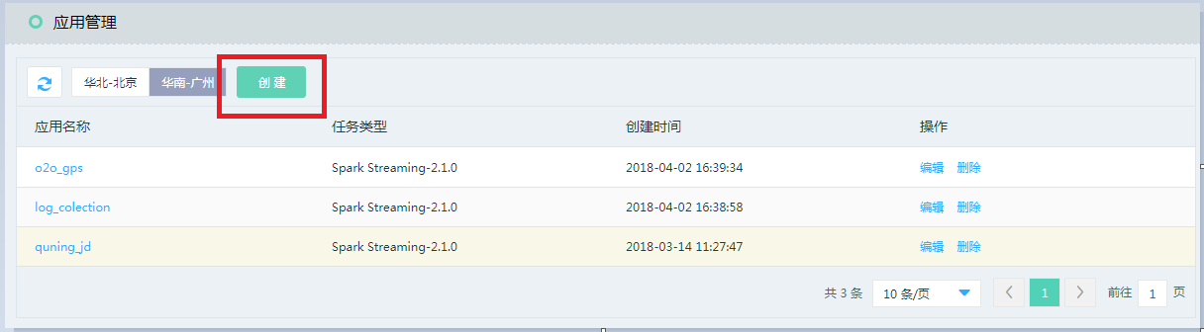

Click “OK” for application creation after data information is input into the application creating interface.

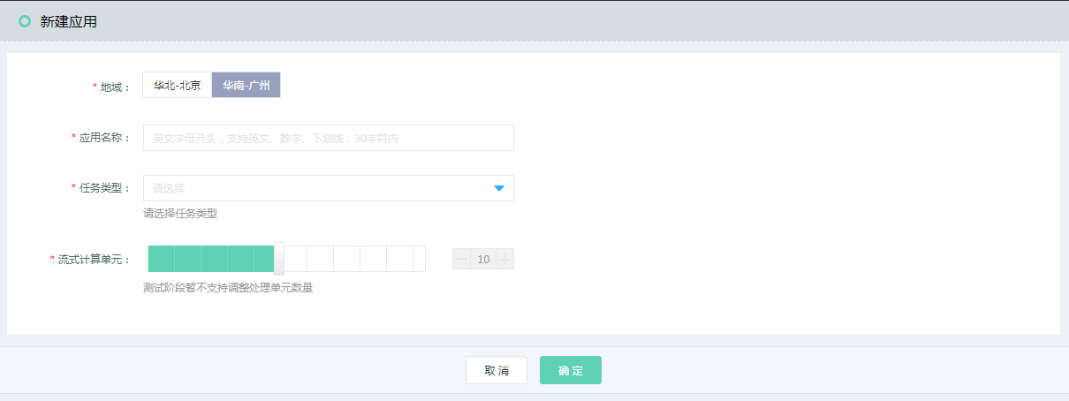

Application name

Create an application name convenient for your memory

Task type:

Bottom computing engines used include spark streaming-2.1.0 provided now and storm and flink which will be provided sequentially.

Streaming computing unit

Stream computing unit: shows computing resources consumed by execution job; one stream computing unit includes one CPU and 4GB memory.

Notes:

* The stream computing unit here is the maximum limit of computing unit you can use in the following.

For example, if you choose 20 stream computing units when creating the APP and create 4 job tasks when entering the APP, you can distribute the computing resources separately for each job task, but the sum of computing resources distributed to such 4 job tasks shall not exceed the number of stream computing units when the APP is created.

##### 3.4.3.1 Data input

Operations:

Click the created application name in the application list page, and then enter the job development page, as shown in the figure below:

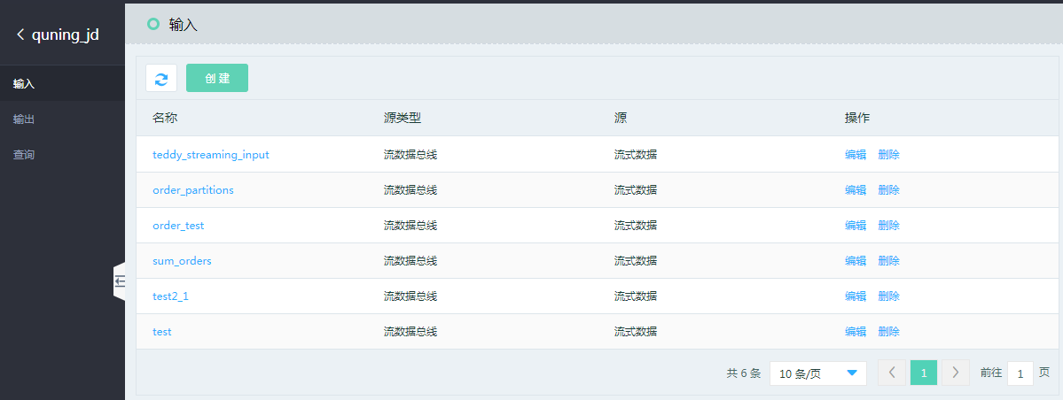

Complete stream computing needs to define three parts, firstly, define “input” of data, namely where the data in stream computing is from.

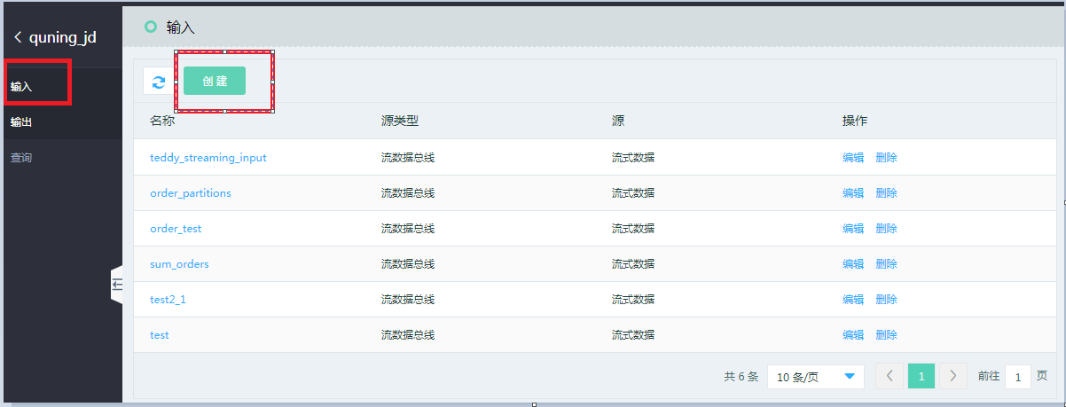

Enter the input source definition page upon “Create”;

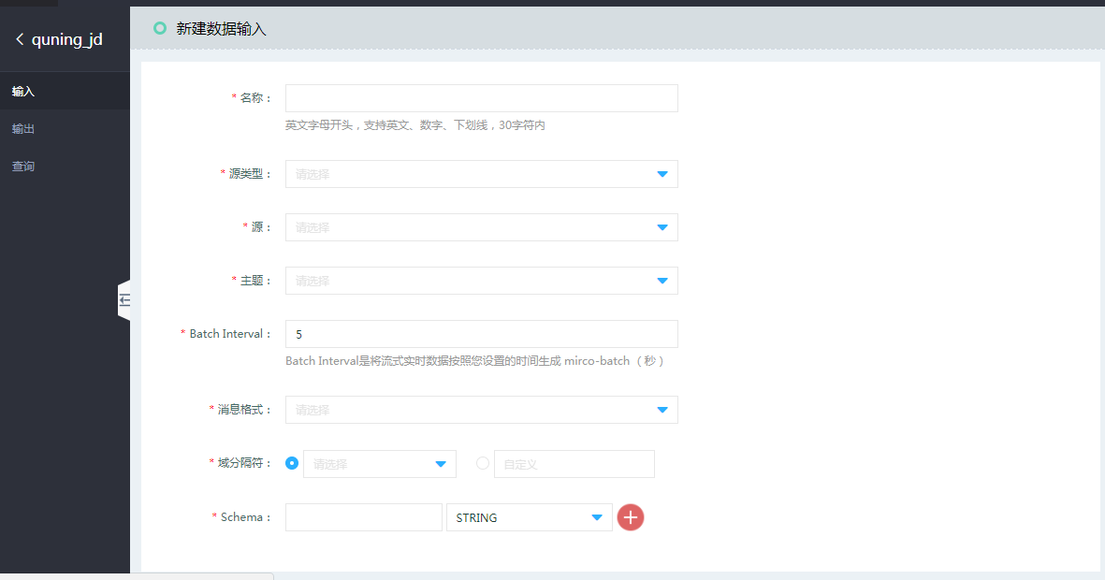

* Name:

Name of the input source is in the SQL sentence of the following inquiry job; tablename of from [tablename] is your defined name here;

* Source type:

You can choose data from “streaming data bus”, and provide more abundant source type in the subsequent revision iteration;

* Subject:

Your created subject name in “streaming data bus”;

* Batch Interval：

Batch Interval will generate mirco-batch (s) based on time you set here;

* Message format:

Message definition format: JSON or CSV;

* Delimiter:

Define delimiter of message in the streaming data bus for data analysis and structural processing;

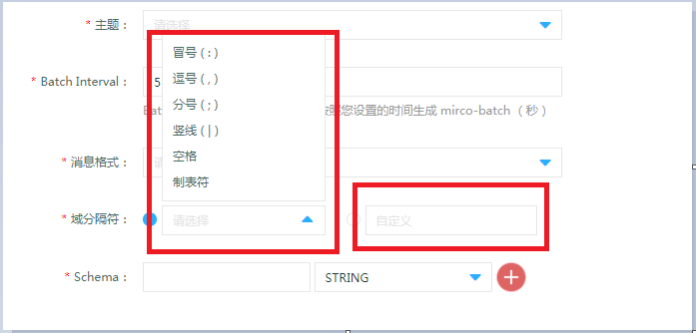

* Schema:

Define the analyzed schema information here after the delimiter is defined; process and analyze data in stream computing after structural processing.

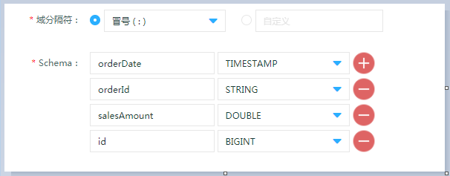

##### 3.4.3.2 Data output

* Output definition:

Define the place to where the data needs inputting upon computing;

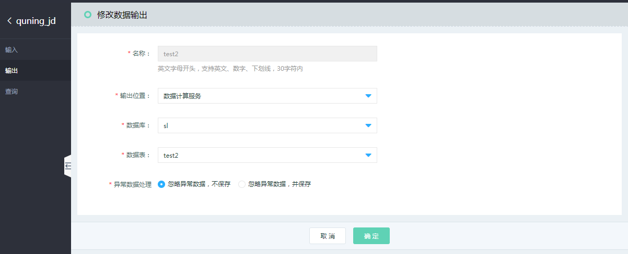

* Name:

Name of output source is in the SQL sentence of the following inquiry job; tablename of into [tablename] is your defined name here;

* Output location:

You can choose where the computed data is output. The currently provided output location is “Data computing service”; more abundant output target end will be provided in the following revision iteration;

* Database:

Name of database in the data computing service;

* Datasheet:

Name of datasheet in the database;

* Abnormal data processing:

Neglect and not save abnormal data: abnormal data will be neglected in case of abnormal data, and constantly run the following compliant data;

Neglect and save abnormal data: Abnormal data will be saved to your appointed cloud storage bucket after the option is started, as shown in the figure below:

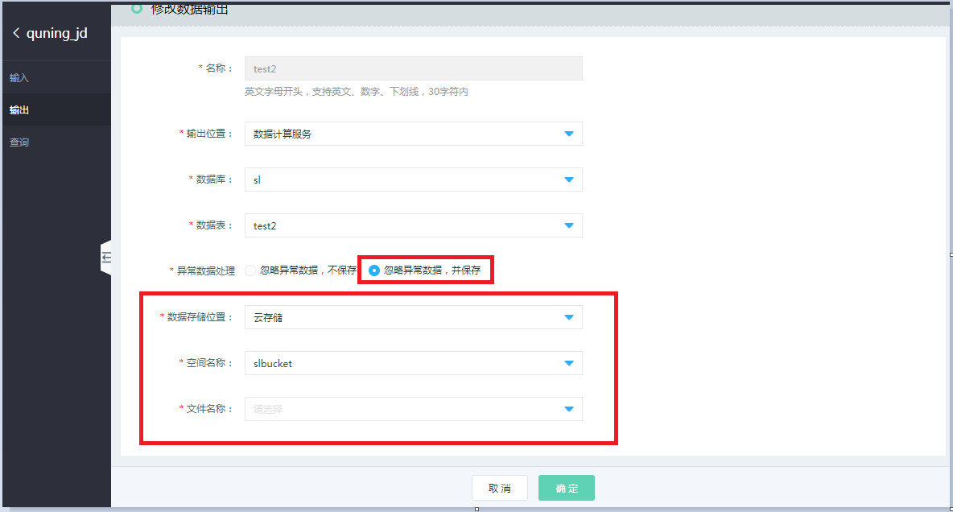

Output definition is output after “OK” is clicked.

##### 3.4.3.3 Job development

1. Search

Inquiry, namely development of stream computing job needs to create a job development task first, and then click “Create” in the figure below:

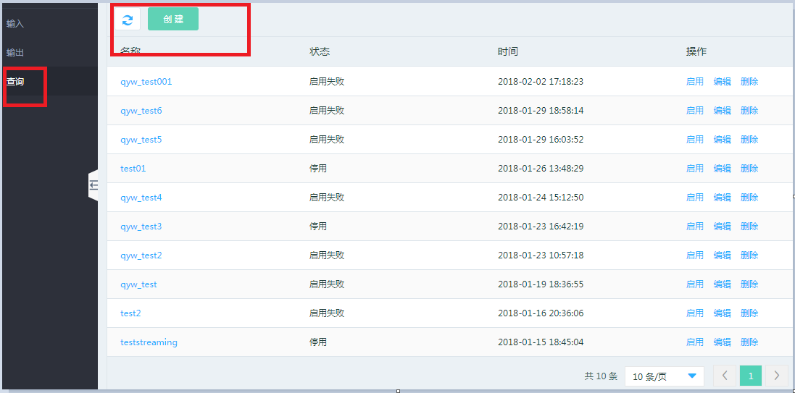

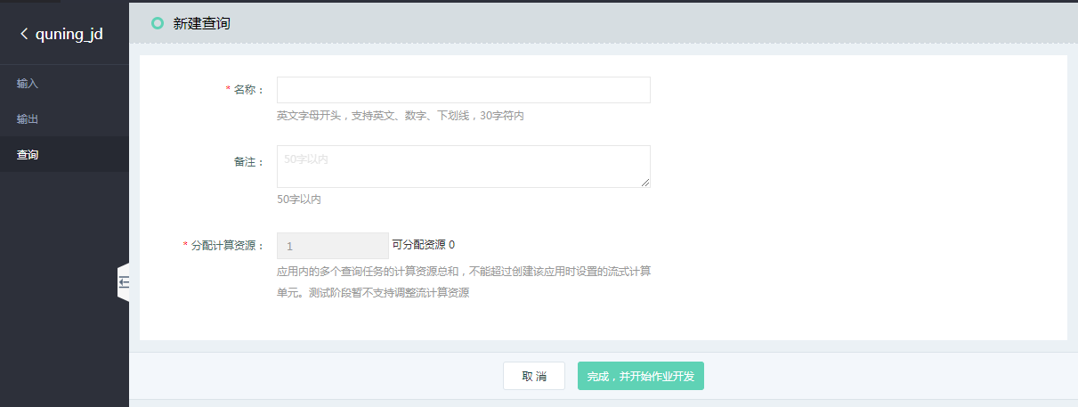

1. Distribute computing resource

sum of computing resources of multiple query tasks in APP, not exceeding the stream computing unit set when such APP is created.

For example, if you select 20 stream computing units when creating the APP and create 4 job tasks when entering the APP, you can distribute the computing resources separately for each job task, but the sum of computing resources distributed to such 4 job tasks shall not exceed the number of stream computing units when the APP is created;

when the creation is complete, click the job name of the query list to enter the development page.

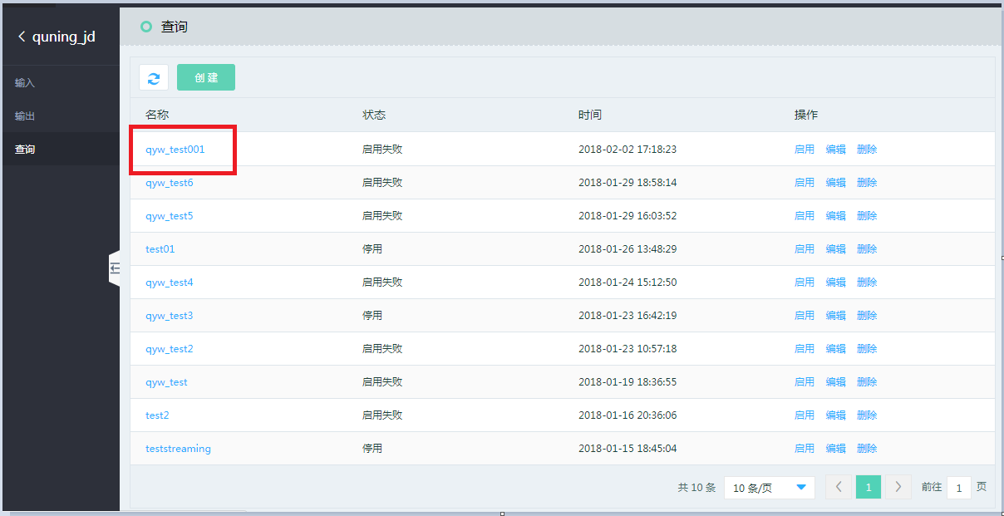

The development of stream-type job is available through SQL method in the development page.

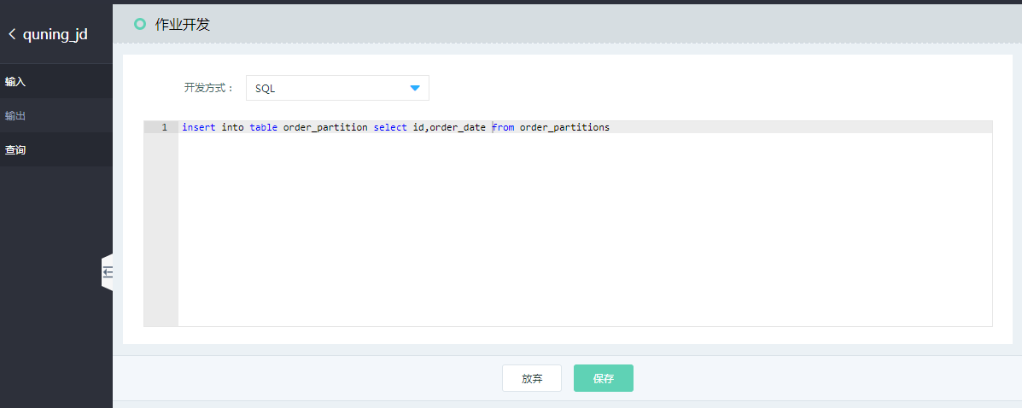

Statement description:

insert into table order_partition select id,order_date from order_partitions

“into table [tablename]” in SQL statement refers to your output target table defined by “output” interface.

“From [tablename]” refers to your input source defined by “input” interface.

When job definition is completed, click “Start” on the query list page to start the job task.

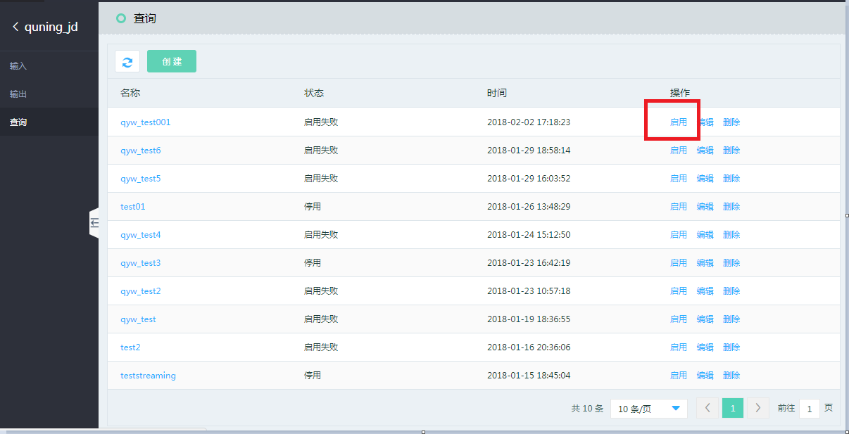

##### 3.4.3.4 Customized function

See <https://www.jdcloud.com/help/detail/2289/isCatalog/1> for customized function details.

### 3.5 JMR

#### 3.5.1 Function overview

JMR (JingDong MapReduce) is a Hadoop/Spark hosted service based on elastic compute capacity and open source ecosystem, by which the user can easily use such low-cost services as MapReduce, Hive, Spark and Presto for big data processing analysis. The user can easily create and start the cluster within few minutes, and preset the optimization of operating system parameters and software configuration, so that the user can focus more on business analysis.

###### 1) Ease of use

JMR supports one-button automatic deployment, and automatic completion of firewall settings, elastic IP binding and other functions based on the selected hardware models (CPU, memory, hard disk) and the selected software combination and version.

###### 2) Cost saving

The cluster can be created with JMR, featuring flexible cost saving, as required. In other words, the cluster is released as soon as the off-line operation ends. The nodes can be increased dynamically, and also long-term operation mode of monthly package can be selected as required.

###### 3) Deep integration of related products

JMR is in close cooperation with other JD Cloud products, e.g. Cloud Storage and Big Data Analysis Platform, as the input source or output destination of Hadoop/Spark computing engine in JMR product.

###### 4) Security and reliability

Each cluster network of JMR is isolated, and the firewall is automatically configured to manage network access, supporting data encryption. The cluster has its own high availability scheme and provides the cluster monitoring management function, which is simple and easy to use.

#### 3.5.2 JMR revision and related software

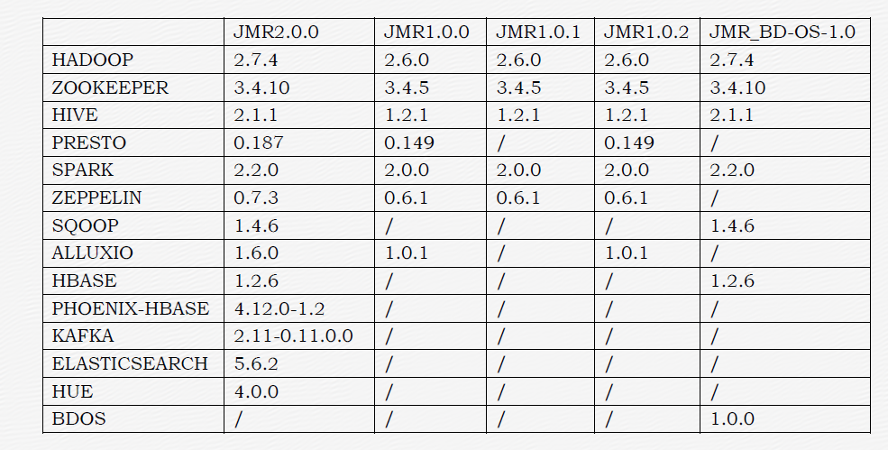

* Introduction to special revision: JMR_BD-OS-1.0

JMR products of BD-OS revision additionally integrates data application product on the basis of JMR products, like user portrait tag, personalized recommendation, data capture system and text analysis system, to provide ultimate customers with more friendly easy-to-use and powerful big data management platform services.

JMR1.X and JMR2.X revisions are mainly for off-line computing service of big data.

#### 3.5.3 JMR billing instructions

JMR is billed by usage in the following standard:

* JMR is billed by the actual usage of the resource, and the statistical time is accurate to the second;
* Billing item: Virtual Machine cost + Cloud Disk cost + EIP cost + JMR product service charge (no discount);
* Arrear: The bill will show the arrear state in case of insufficient balance during fee deduction. The service will be stopped for 3 days and data be deleted after 7 days; JMR service will be automatically stopped in case of arrear, and fee deduction will be stopped. Your data in JMR cluster will be kept for 7 days from the moment of stopping service, and the system will recover the resources after 7 days, in which case the data cannot be retrieved.
* Renew: If you top up to pay up the arrearage within 15 days since the arrearage, the service will be started automatically for use; if not top up to pay up the arrearage within 15 days, you are deemed to give up the JMR service.

Note:

* Refer to Virtual Machine billing rules for the Virtual Machine cost in billing items.
* Refer to Cloud Disk billing rules for the Cloud Disk cost in billing items.
* Refer to EIP cost billing rules for the EIP cost in billing items.

#### 3.5.4 Operation guide

##### 3.5.4.1 Quick start

The relevant operation procedures shall be familiarized for quick start before the use of JMR service:

1. Real-name Verification

Register JD Cloud account and finish real-name verification firstly before the use of JMR service.

1. Data preparation

User can choose uploading data files locally and the local uploaded files are saved in HDFS by default.

In addition, user can select uploading the data document to the object storage server.

1. Create cluster

Purchase the cluster first. The cluster purchase number is limited by the elastic cloud server quota.

1. Import data

When the cluster is created, the data in the object storage service can be processed, and the data in HDFS can be processed at the same time.

1. Create job

Different types of jobs can be created on different clusters.

1. Deploy Job

Carry out regular execution or periodic execution, and perform unified deployment plan for multiple jobs at the same time.

1. Check the job execution

The execution history list reflects the final running state of the job, so the use can check the log information of the job execution

1. Release clusters

If the cluster is no longer needed after the use of cluster, the cluster can be released and the system will stop billing automatically.

##### 3.5.4.2 Create cluster

Operations:

1. Log in JMR console;
2. Select the region first, then click “Create” and jump to the “Create cluster” page;
3. “Create cluster” includes the following four points:

Basic Information

1. Resource name

Rules description: Must provide a name, only support Chinese, numbers, capital and lowercase letters, English underline “_” and line-through “-”, with the length of 6-32 characters.

2. Remote login password:

**Rules Description:**

1) It must include three types of the capital letters, lowercase letters, numbers and special characters, and cannot be less than 8 characters nor exceed 30 characters;

2) Special characters are as follows: !@#$%^*;

3) Characters or complete words that cannot be included are as follows: jd, JD, 360, bug, BUG, com;

4) Consecutive numbers cannot be included, such as 123 and 987;

5) Consecutive or key mapping consecutive letters cannot be included, such as abc, CBA, bcde, qaz, tfc and zaq;

6) Personal user name cannot be included in the password

3. Confirm password:

Rules Description: Same as above.2. Remote login password.



**Software setting**

1. JMR revision

The current JMR revision can be configured as required.

2. Software list

The software list corresponding to each revision is different based on JMR revision, and the optional software is different.

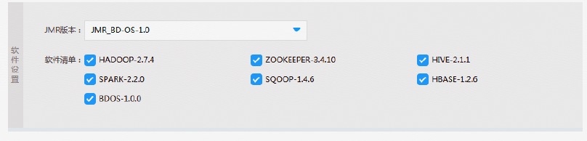

1. High availability

* The cluster has two Masters when high availability is initiated, that is, Active Namenode and Standby Namenode;

Two Namenodes form mutual backup, in which one stays at Active state, as the primary Namenode, and the other stays at Standby state, as the backup Namenode. Only the primary Namenode can provide read and write services externally.

* The cluster has one Master by default when high availability is not initiated.
* JMR_BD-OS-1.0 revision selects high availability by default when creating the cluster.

2. Master node information

* Meaning: Instance node is mainly responsible for the deployment of control process like Namenode and ResourceManger.
* Node specification: General Shared, General Standard, Compute-Optimized Standard, Memory-Optimized Standard.
* The default memory size of system disk is 30GB.
* Data disk type: capacity-oriented, performance-oriented.
* Capacity of data disk: It must be the integral multiples of 10, but greater than 20 and less than 3000GB.
* Actual quantity: the quantity is 2 if high availability is available, otherwise 1.

3. Core node information

* Meaning: Core instance node and computing node are mainly responsible for all data storage and computing in the cluster.
* Node specification: General Shared, General Standard, Compute-Optimized Standard, Memory-Optimized Standard.
* The default memory size of system disk is 30GB.
* Data disk type: capacity-oriented, performance-oriented.
* Capacity of data disk: It must be the integral multiples of 10, but greater than 20 and less than 3000GB.
* Actual quantity: the available quota is prescribed by the Virtual Machine. The current quota rule is: for single account in every region (South China or North China), the respective aggregate limit of the Virtual Machine and Cloud Disk is 20.



**Network setting**

1. Network type: select “Virtual Private Cloud” by default.

2. Virtual Private Cloud: available to create new VPC or customize VPC.

If it is needed to create virtual private cloud, please log in “JD Cloud - Network - Virtual Private Cloud” page for settings.

3. Associated object storage

“Yes” means that you can run the data in object storage service.

“No” means that you cannot run the data in object storage service.

4. Select security group

“The default security group allows all traffic” is only supported at present. Please refer to “Virtual Machine - Security Group” list for details.

5. Create public IP and bind the same: select this item by default.

Create a 5M-bandwidth Public IP by default.

6. Network ACL

Associate the new VPC subnet with ACL rules by default.

The inbound rules only allow opening the ports 22 and 8080 by default.

Refer to “Network - Virtual Private Cloud - Network ACL” for details. You can revise and create ACL rules as required.



e) Click “Purchase Now” on the right side of the page to complete the cluster creation.

f) The time for cluster creation is about 10 minutes (note: the creation time is related to the cluster scale), and you can check the cluster creation status and cluster details on the Cluster Management page.

##### 3.5.4.3 Create operation

Operations:

1. Select the ”Job Management” page, then click “Create” and jump to the “Create job” page
2. Step 2 “Create job” page includes the following contents:

* Select a cluster

You can select the available cluster of the local region here.

* Job name

Support Chinese, numbers, capital and lowercase letters, English underline “_” and line-through “-”, with the length of 6-32 characters.

* Job type

The job type displayed here is related to the software list ticked when creating the cluster. Available cluster does not support the temporarily increase of job types. A new cluster can be created if the job type needs to be added.

* Select file

Selection the locally uploaded script.

* Application program location

Selection the local upload with the default HDFS route: hdfs:///jmr/filename.txt

* Application program parameter

Execute the corresponding command specification based on the selected job type.

* Actual execution

Have default value based on the selected job type.

1. click “Save” or “Save and execute”.



##### 3.5.4.4 Job development

1. Select the ”Regular Task” page, then click “Create” and jump to the “New task” page
2. “New task” page includes the following contents:

* Task name

Support Chinese, numbers, capital and lowercase letters, English underline “_” and line-through “-”, with the length of 6-32 characters.

* Execution policy: divided into single execution and periodic scheduling.
* Schedule time

Single execution: available to select the time;

Periodic scheduling: per day, per week or per month.

* Job selection

Selection the any job displayed below.

1. Click “Save”.



##### 3.5.4.5 Cluster monitoring

Cluster monitoring currently involves monitoring node instance (VM) and cluster service status.

Operations:

1. Choose “Cluster management” page; click “Monitor” to enter the cluster service status page.
2. “Monitor” page has the following contents:

The displayed software service item is associated with the selected list based on cluster creation.

Service status and reporting time of every node.

Refresh the page to update service status and report time.



1. Node instance monitoring

Cluster consists of a variety of VM instances which mean VM. User could view the monitoring status of instance in “Management - Cloud Monitor - VM” by virtue of searching the machine name.

##### 3.5.4.6 Remote guidance

1. User access

JMR cluster node supports two kinds of user access; including Web interface login and SSH login;

* Web interface login

Notification Information:

|  |
| --- |
| 1. JMR cluster starts the related services of Hadoop/Spark by default upon creation. You could provide direct access to WebUI of the related Hadoop services by means of the associated Public IP plus service port.  2. The access address of the cluster - (heyuzhidemo) Master Web is as follows: Public IP: 116.196.66.247; port: the corresponding port is applied according to different applications; common application access entrance: HDFS Web management: 116.196.66.247:50070  (Ports 22 and 8080 can be accessed only at present; please set the network ACL if there is a necessary to provide access to other ports)  3. JMR believes you create and associate the firewall by default while creating the cluster. Please view any access problem.  1) Private IP and Public IP of Master node are associated properly.  2) Hadoop/Spark and other application service configurations are modified. The modified port is used for access in case of any modification. |

* SSH login

Notification Information:

|  |
| --- |
| 1. JMR associates Public IP to the Master node of cluster. You can log into the server for systematic operation remotely by means of SSH tool (for instance, PuTTY).  2. The cluster - (heyuzhidemo) Master SSH access address is as follows: Public IP: 116.196.66.247; port: 22; login account: root. You could log in it with the remote login password set when you create the cluster.  3. JMR believes you create and associate the firewall by default while creating the cluster. Please view any login problems.  1) Private IP and Public IP of Master node are associated properly.  2) JMR defaults whether the firewall policy is modified, for instance, the corresponding port is modified. |

1. Log in Master node

Introduce how to log in the cluster Master node by virtue of WEB interface and SSH

* Web interface login

Input the Public IP to view the management interface according to the notification information.

Notes: refer to Article 6. Network ACL in “Create cluster - network setup”

* SSH login

Step 1: use root user to log in Master node remotely by means of SSH tool according to the notification information.

 

Step 2 Common command

1. Execute the following commands to switch the user

[root@OmkZafrH-Master1 ~]# sudo su -hadoop

2. View node running service progress

[hadoop@OmkZafrH-Master1 ~]$ jps

9344 RunJar

6675 ApplicationHistoryServer

5028 QuorumPeerMain

5190 DFSZKFailoverController

4840 JournalNode

7386 HMaster

4765 Bootstrap

19757 Jps

8685 JobHistoryServer

9550 ResourceManager

5455 NameNode

10287 RunJar

3. View software install location and software dictionary

Software is put in data0 file of the root dictionary

[hadoop@OmkZafrH-Master1 ~]$ cd /data0/

[hadoop@OmkZafrH-Master1 data0]$ ll

total 56

drwxr-xr-x 9 hadoop hadoop 4096 Oct 31 18:07 apache-hive-2.1.1-bin

drwxr-xr-x 6 root root 4096 Apr 10 17:42 bdos

drwxr-xr-x 3 root root 4096 Apr 10 17:41 bfd

drwxr-xr-x 5 root root 4096 Apr 10 17:43 hadoop

drwxrwxrwx 11 hadoop hadoop 4096 Apr 10 17:42 hadoop-2.7.4

drwxr-xr-x 7 hadoop hadoop 4096 Oct 31 12:21 hbase-1.2.6

drwx------2 root root 16384 Apr 10 17:39 lost+found

drwxr-xr-x 4 root root 4096 Apr 10 17:41 var

drwxr-xr-x 3 root root 4096 Apr 10 17:43 yarn

drwxr-xr-x 3 hadoop hadoop 4096 Apr 10 17:42 zookeeper

drwxr-xr-x 10 hadoop hadoop 4096 Mar 23 2017 zookeeper-3.4.10

4. View environment variable

[hadoop@OmkZafrH-Master1 data0]$ vi ~/.bashrc

# .bashrc

# Source global definitions

if [ -f /etc/bashrc ]; then

. /etc/bashrc

fi

# User specific aliases and functions

export HBASE_HOME=/data0/hbase-1.2.6

export PATH=$PATH:$HBASE_HOME/bin

export HBASE_HOME=/data0/hbase-1.2.6

export PATH=$PATH:$HBASE_HOME/bin

export HIVE_HOME=/data0/apache-hive-2.1.1-bin

export PATH=$PATH:$HIVE_HOME/bin

export HADOOP_HOME=/data0/hadoop-2.7.4

export PATH=$PATH:$HADOOP_HOME/bin

export HADOOP_LOG_DIR=/data0/var/log/hadoop

export HTTPFS_LOG=/data0/var/log/httpfs

export HADOOP_HOME=/data0/hadoop-2.7.4

export PATH=$PATH:$HADOOP_HOME/bin

export HADOOP_LOG_DIR=/data0/var/log/hadoop

export HTTPFS_LOG=/data0/var/log/httpfs

export ZOOKEEPER_HOME=/data0/zookeeper-3.4.10

export PATH=$PATH:$ZOOKEEPER_HOME/bin

export ZOO_LOG_DIR=/data0/var/log/zookeeper-3.4.10

1. Log in BD-OS revision JMR

Such revision mainly introduces Web interface login method.

Step 1: copy Public IP and domain name (114.67.248.172 bdos.jcloud.com) to hosts file in C:\Windows\System32\drivers\etc based on the prompt information accessed by web.

Step 2: open port 80 inbound policy for the domain name meets HTTP protocol and the port is 80. For this, the inbound policy of the port 80 needs opening. Set network ACL in the “Network - Virtual Private Cloud - Network ACL”; choose the inbound rules and new rules for edit - add; click for saving upon editing. See the figure below.



Step 3: open browser, and input bdos.jcloud.com

Step 4: show the login page successfully.

